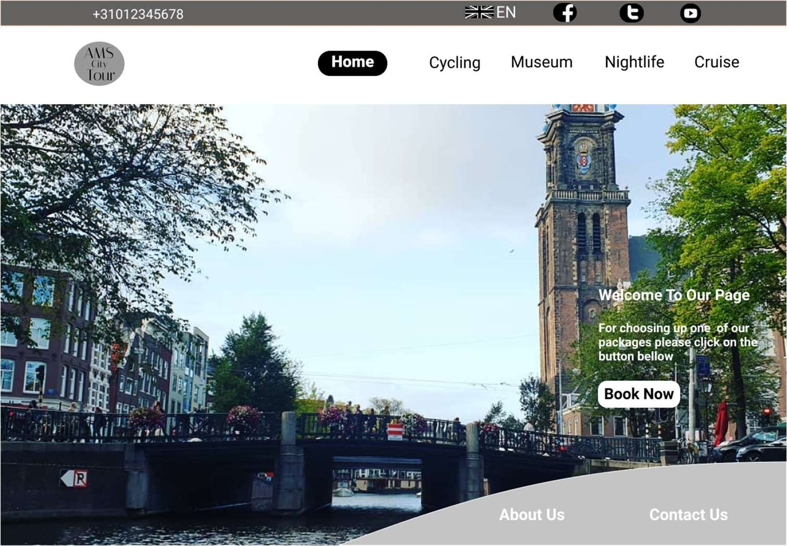*Figure 1: Home page*

TEMPLATE LOGBOOK

WEBDESIGN

Static website

WEBSITE DESIGN NAME

a website about travelling in Amsterdam for international people

#### Name: Md Tasnim Kabir

Studentnumber: 658116

Link to design

<

https://[www.figma.com/file/](http://www.figma.com/file/) 0rfAoWjjl5DHrQn3zv21ju/ Untitled?node-id=214%3A2

>

19-10-2021 21:49:02

### Contents

Introduction 2

Assignment 1: ..……………………………………………………………………………3 5

Assignment 2a: 6—9

Assignment 2b 10

Assignment 3: 10-14

Assignment 4 (Version1) : 14-28

Assignment 5 (Version 2) : 29-38

Figma Link 39

Self Assessment : 40-41

Sources 41

Hours Justification 42

### Introduction

I am going to create an website for international tourists those who want to visit in Amsterdam. In my website , I highlighted some popular places in Amsterdam to visit.

### Assignment 1:

#### Date: 06-09-2021

Today first I have created my project proposal because it is mandatory for going to the next step. I created this project proposal by using word document and also taking some help form online.

First, I choose another topic and started work on it. But When I finished this task, then I got understand that this doesn’t fulfill the requirement. So, I deleted most of the staff and write

everything them again.

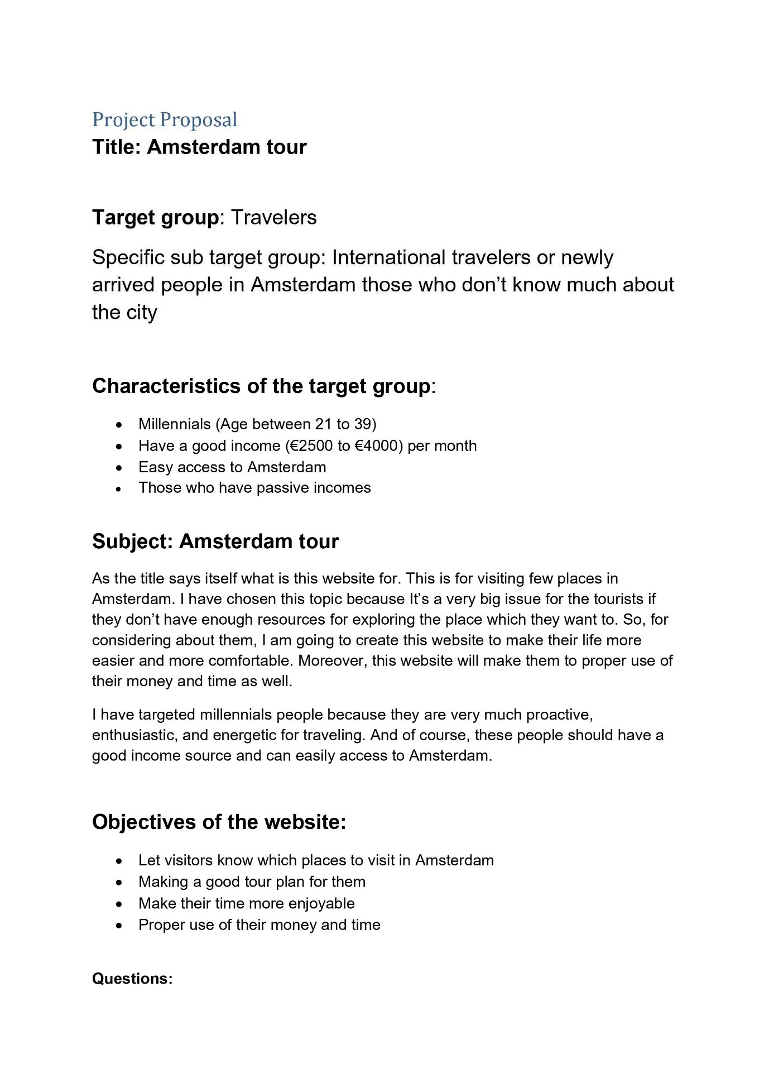

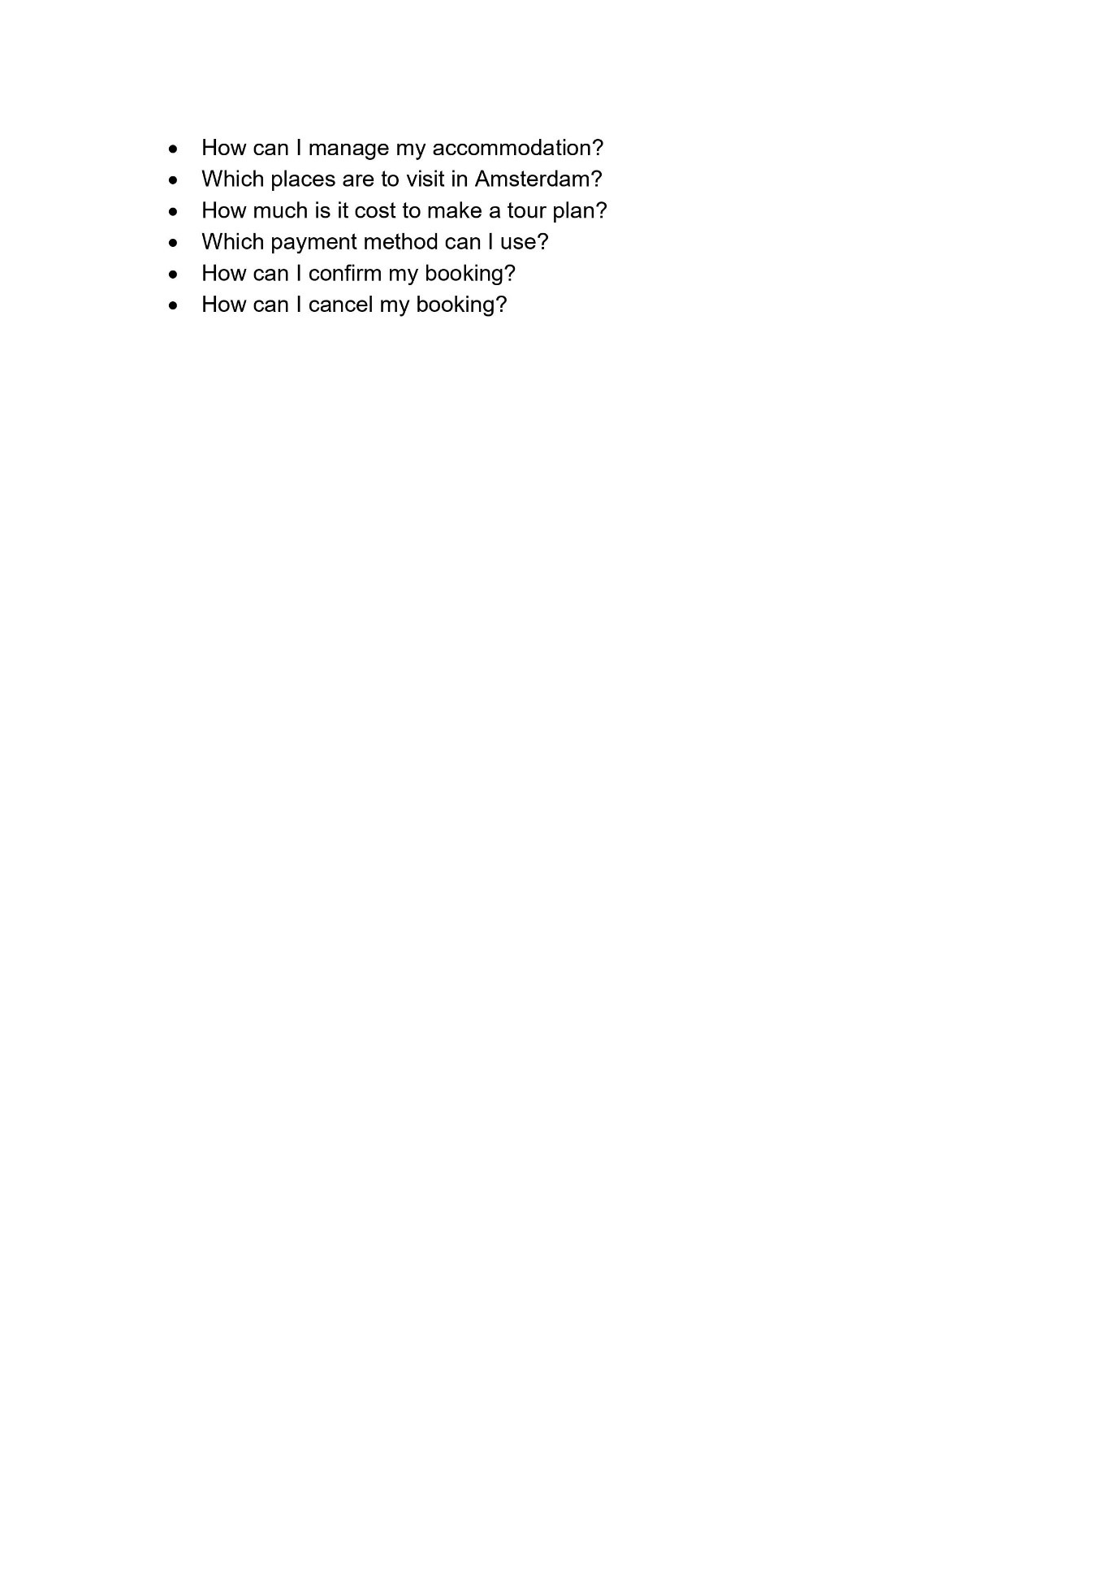

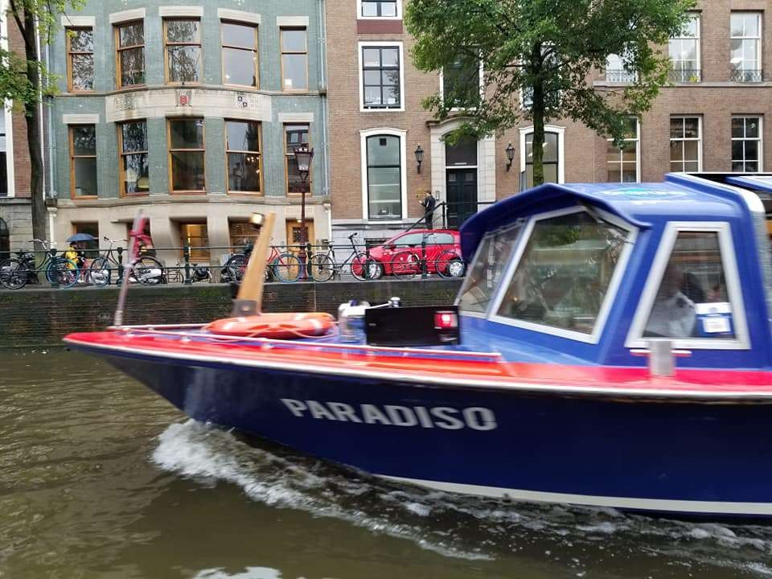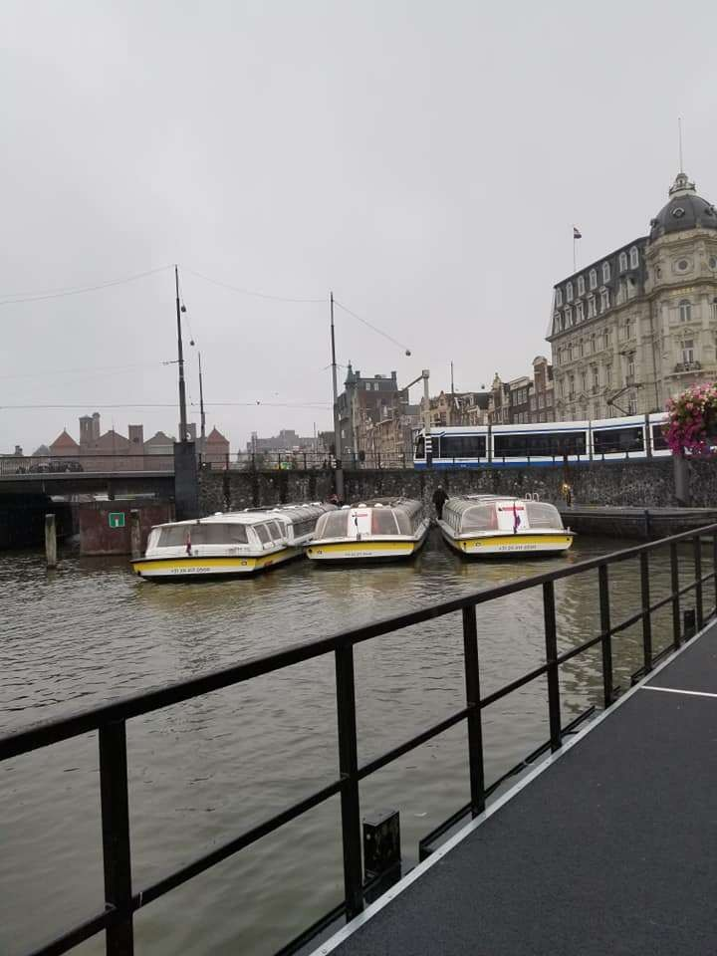

### Assignment 2a:

#### Date: 12-09-2021

Homepage:

Are you planning to visit in Amsterdam, want to discover the city by boat , want to visit one of the world-famous museums, want to enjoy the nightlife then you are in the right place. To see all of our travel packages click on the button bellow.

Book Now

Cruises:

Cruises and Boat Tours Highlights

* The duration is one hour
* See the best things about Amsterdam from water
* Relax, enjoy and take beautiful pictures

Amsterdam in One Hour!

What you can expect from us during this one hour?

We cover almost the whole city in this one hour and we ride our boat slowly so that people can take a lot of pictures ,see the city properly and also enjoy the Amsterdam from boat.

Moreover ,we provide a free drink to all.

##### Discover the best of the city on a canal boat!

A fun Amsterdam canal cruise is a great way to get to know one of the most popular tourist destinations in Europe. During this travel you can see the most popular places in Amsterdam like Anne Frank House Museum, de Pijp, de Wallen etc .

So get on a canal boat and don't miss this fun Amsterdam adventure

##### Discount on your canal cruise ticket!

Book your Canal Cruise tickets directly through our website and get 10% discount. So, hurry up now.

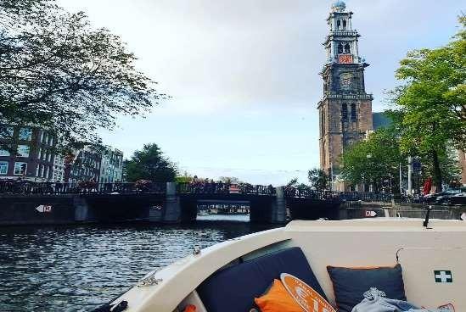

Museums:

**Rijkmuseum:**

Highlights:

* Discover Dutch masters such as Rembrandt, Vermeer and Van Gogh
* See the world famous *The Night Watch* and the *Milkmaid*
* Includes access to certain special Rijksmuseum exhibitions The National Museum of the Netherlands

The Rijksmuseum is the largest art museum in the Netherlands and has an impressive collection of world-famous works by masters such as Vincent van Gogh, Johannes Vermeer, Frans Hals and Rembrandt van Rijn. Using both works of art and historical objects, the National Museum of the Netherlands looks back on more than 800 years of Dutch history.

Visit one of the best museums in the Netherlands

The Rijksmuseum takes you from the Middle Ages to Mondrian. In addition to beautiful works of art, the museum also houses a collection of dolls' houses, ship models and weapons. And the Cuypers Library is the largest and oldest art-historical library in the Netherlands. Visitors, students and art historians can come here to delve into the collection of the Rijksmuseum.

**Discount on your Rijkmuseum ticket!**

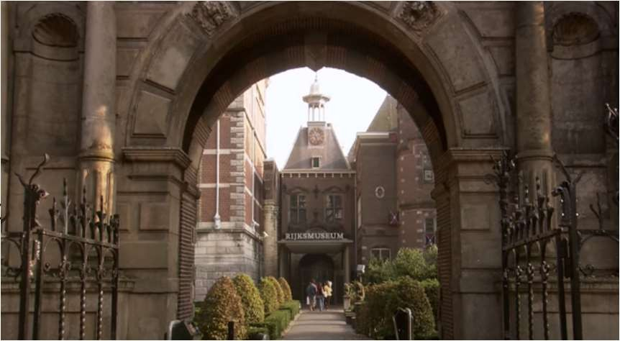Book your Rijkmuseum tickets directly through our website and get 10% discount. So, hurry up now.

7

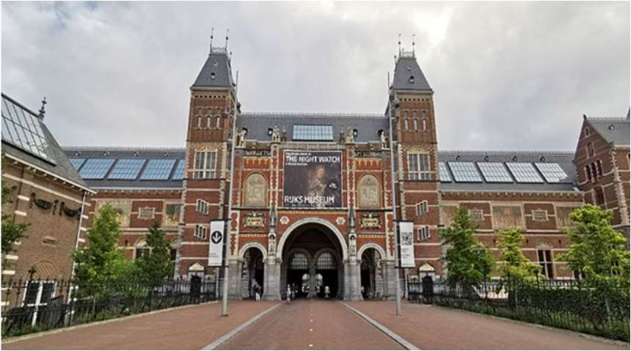

d

* + A trilingual live guide (English, Dutch, and Spanish)
  + Discover the Venice of Nederland

Cycling:

###### Highlights

* + Cycle through the Amsterdam city
  + See all the highlights of the city
  + Meet new friends along the way

###### Through Amsterdam by bike

This bike tour gives you a fascinating picture of the famous and rich history of Amsterdam. During the two-hour bike ride you will come to interesting places, such as the

harbor, the charming Jordaan, the Anne Frank house, the Westerkerk, and the Rijksmuseum.

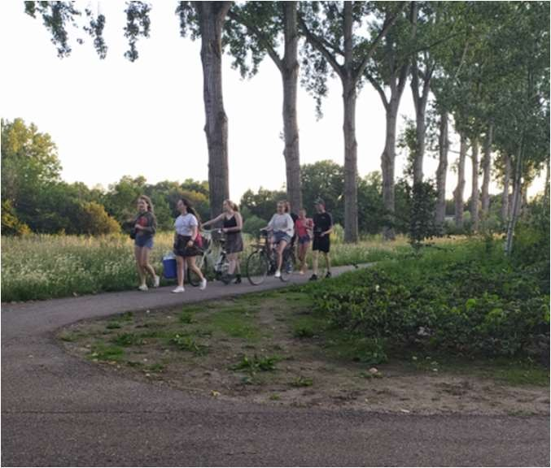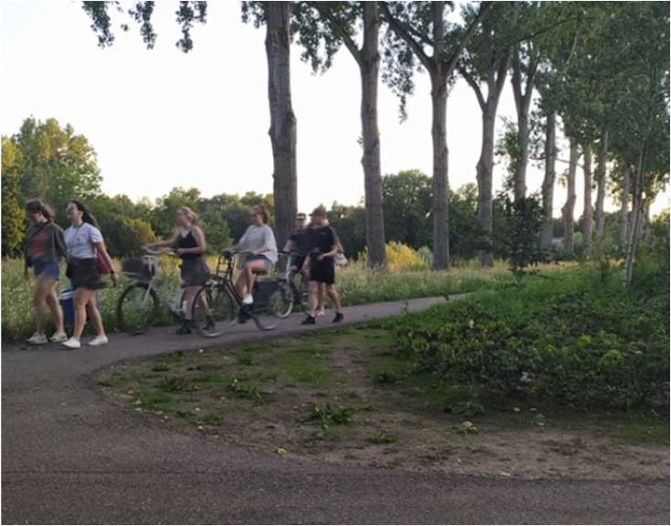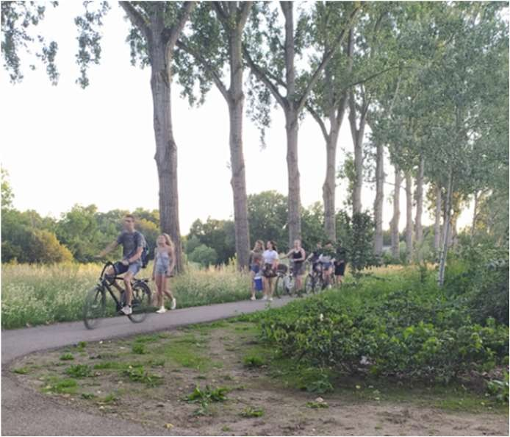

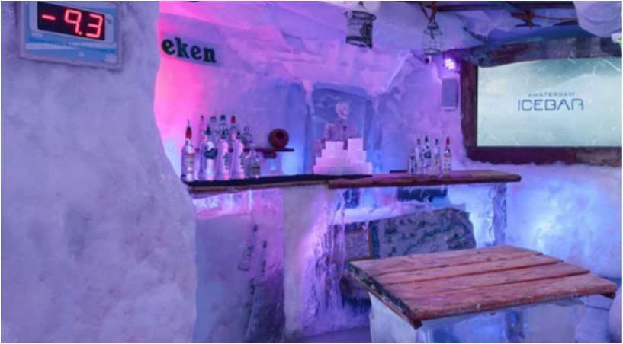

## Amsterdam Nightlife:

Highlights:

* + - Enjoy 3 drinks, included with your ticket
    - Join explorer Willem Barentsz to the Arctic
    - Stay warm during the freezing cold experience with a jacket and gloves Amsterdam Ice bar: Nova Zemlya

The Amsterdam ice bar is one of the coolest places in the city and is definitely in the top 10 things to do in Amsterdam. This amazing bar is kept at a constant temperature of -10 degrees Celsius and everything is made of ice.

What can you expect from a visit to the Amsterdam ice bar?

The bar consists of two parts: a 'warm' bar and the ice bar itself .In the warm bar they offer a wide choice of alcoholic and non-alcoholic drinks. You can use your token for a beer, glass of wine, cocktail, shot, soft drink or a hot drink. While you enjoy your drink, you will be introduced to Willem Barentz, one of the most famous Dutch explorers of the 16th century, who invites you to join him on his journey to find the Northeast Passage to the Indies.

After that, you'll be given appropriate clothing for the trip to the North Pole and enter the ice bar where everything from the furniture to the walls and art is made entirely of ice. The ice bar represents the island of Nova Zemlya, where Barentsz and his crew were stranded for almost a year. At the bar you can order beer, shots or orange juice with your two silver tokens, served in ice glasses of course!

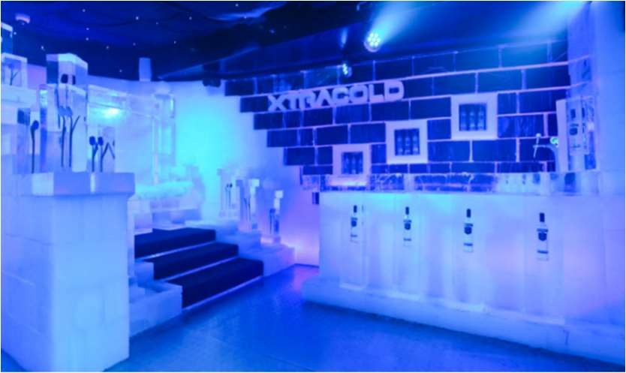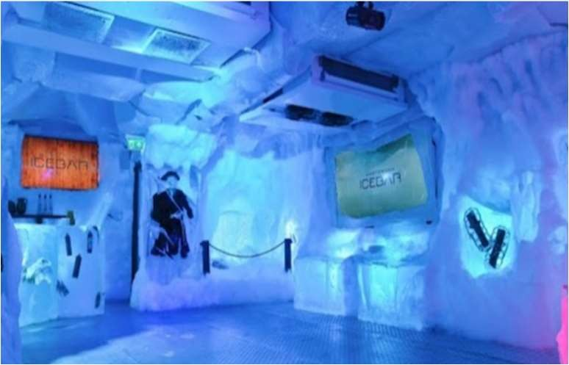

### Assignment 2b:

Date: 23-09-2021

Here is my logo and favicon



### Assignment 3:

#### Date: 27-09-2021

This is the scratch of my home pages and detail pages

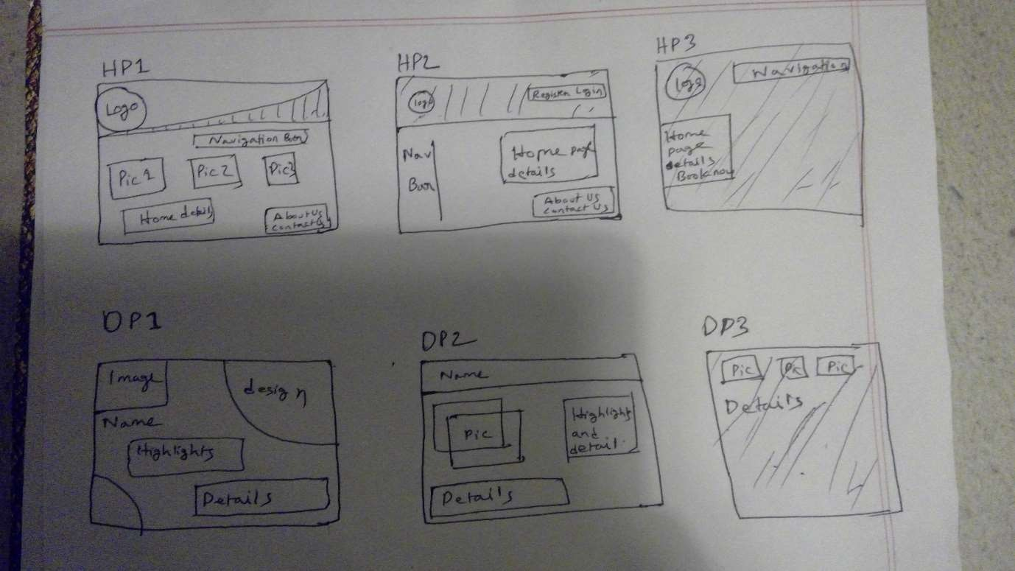

Home page 1

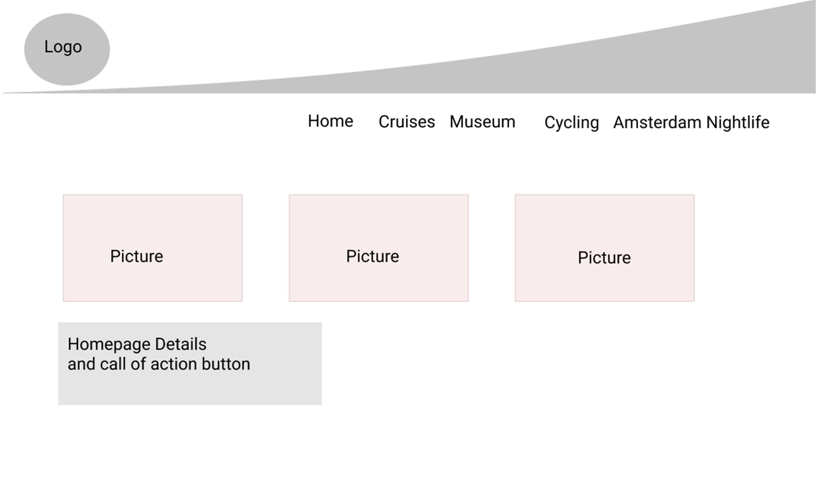

Home page 2

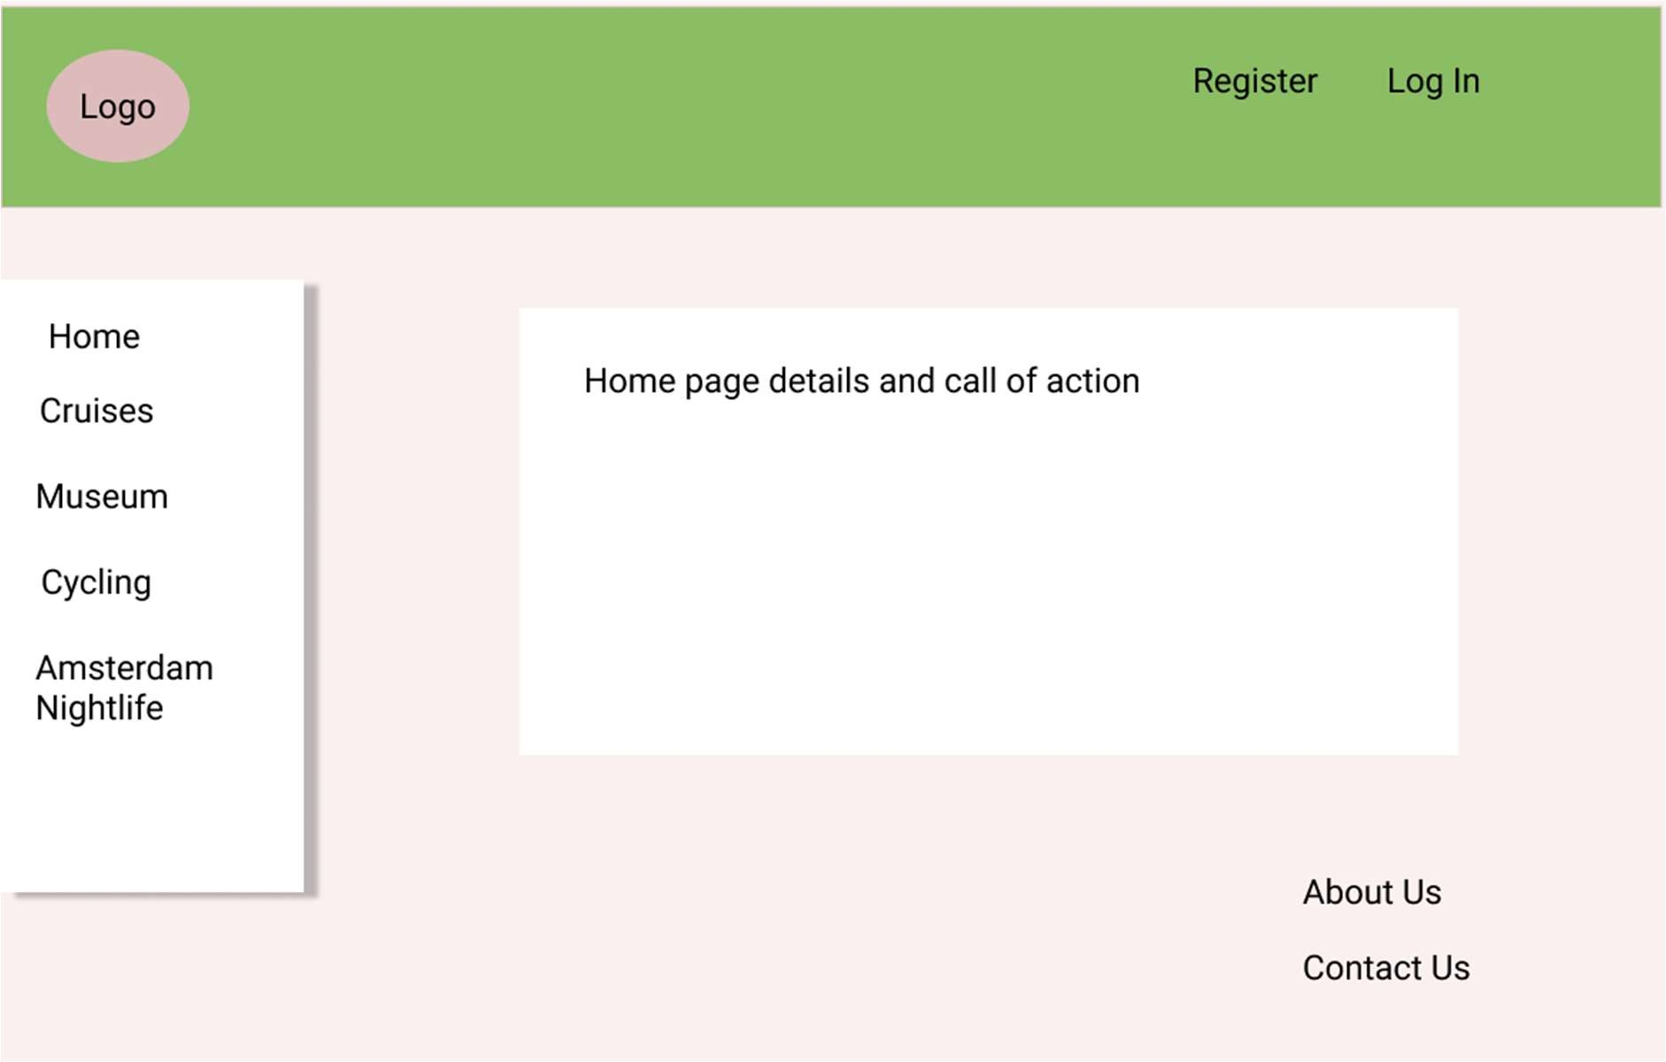

Home page 3

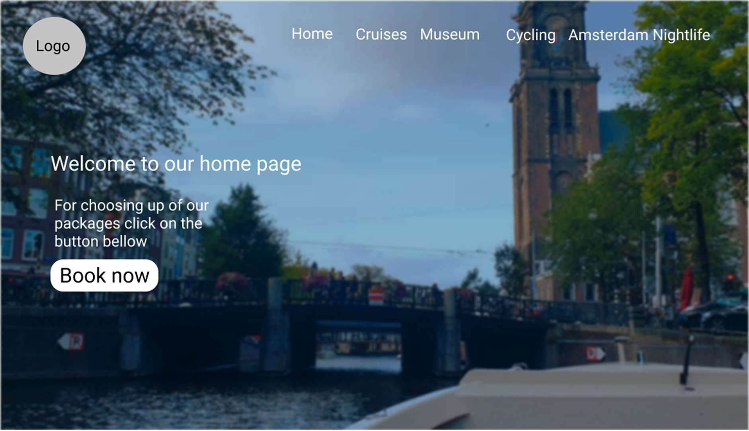

Details page 1

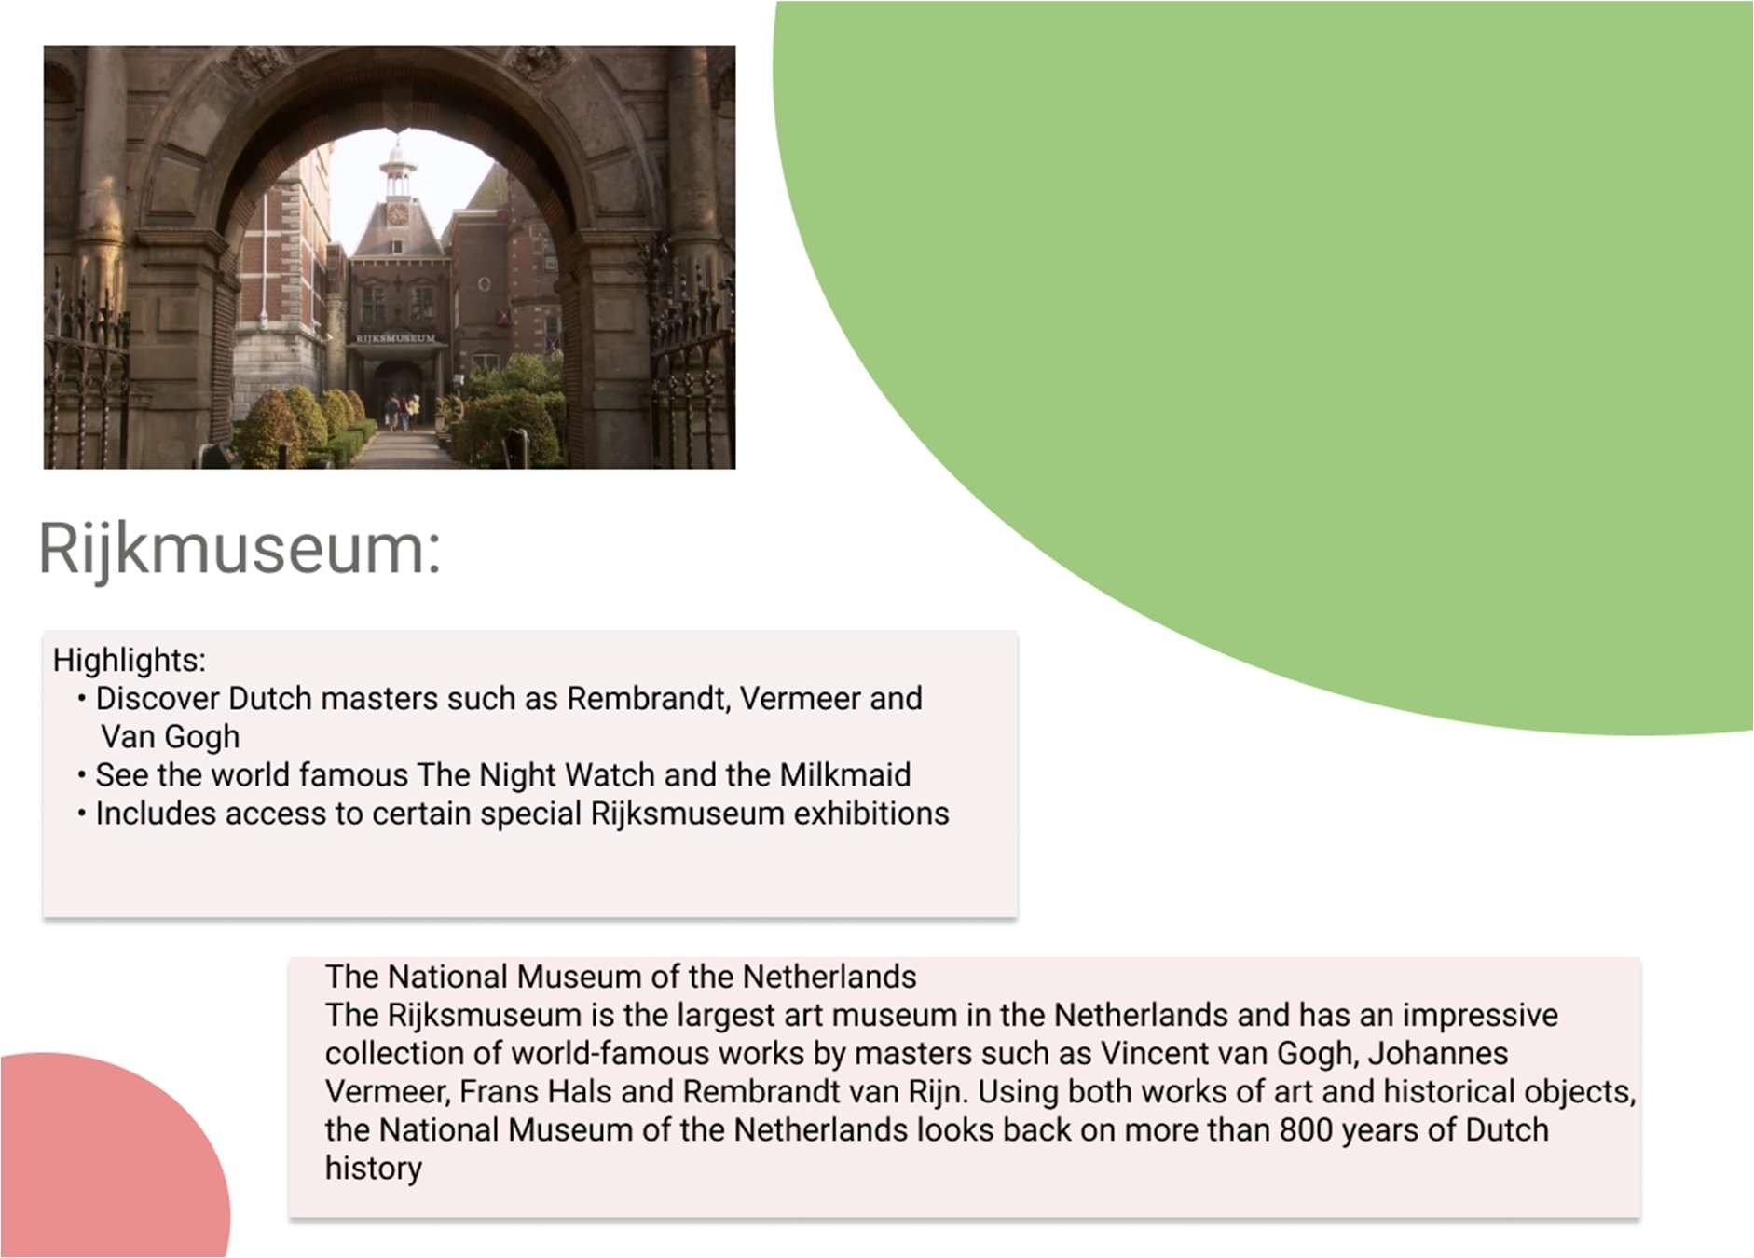

Details page 2

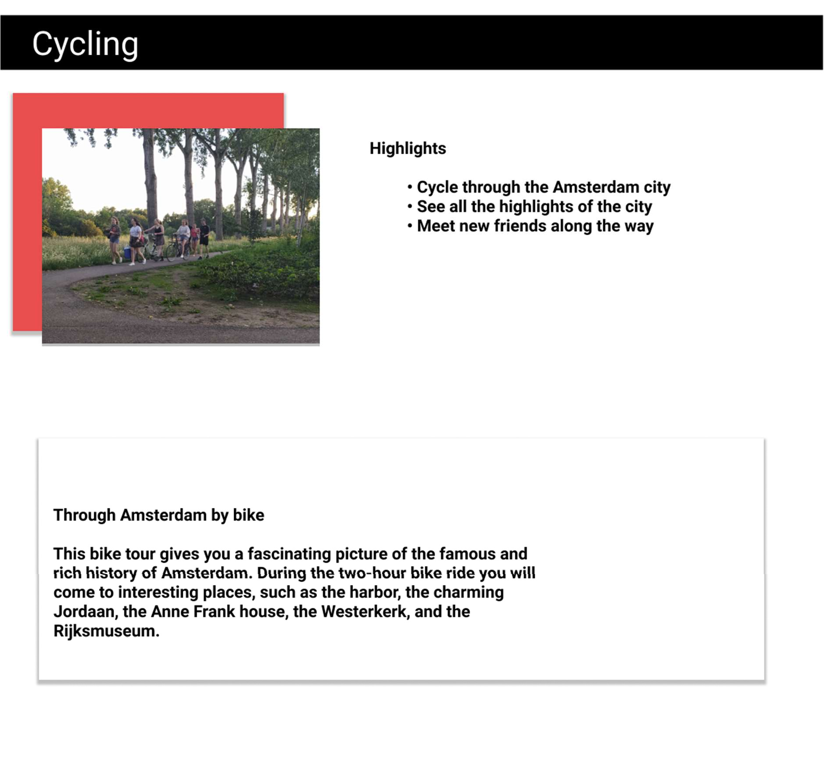

Details page 2

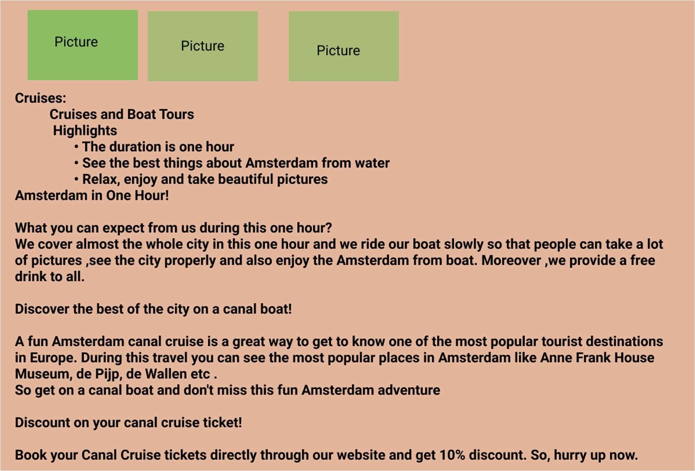

Details page 3

### Assignment 4:

#### Date: 27-09-2021

This is for the desktop

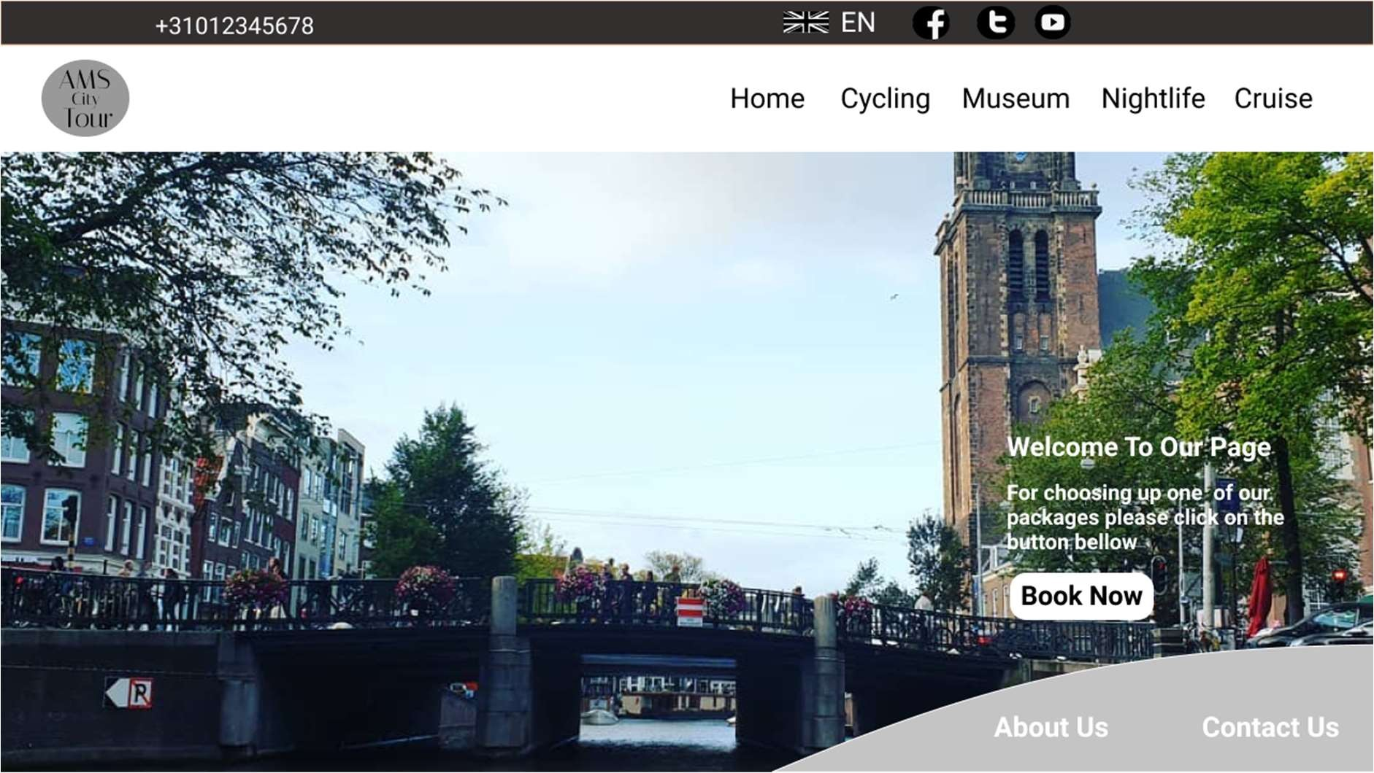

This is the home page of my website .As you can see , on the top there is one header. Under that , there is one navigation bar where I have creted my navigation menus, and on the top left corner there is my website logo.

I have created my website body by using a picture and on the middle right corner of the body , there are homepage details and call of action button.

Bellow that , it has footer menu where I created about us and contact us form.

This is the first details page of my website . When you will click on Cycling then it will open this file and you can find all the details about cycling in Amsterdam.

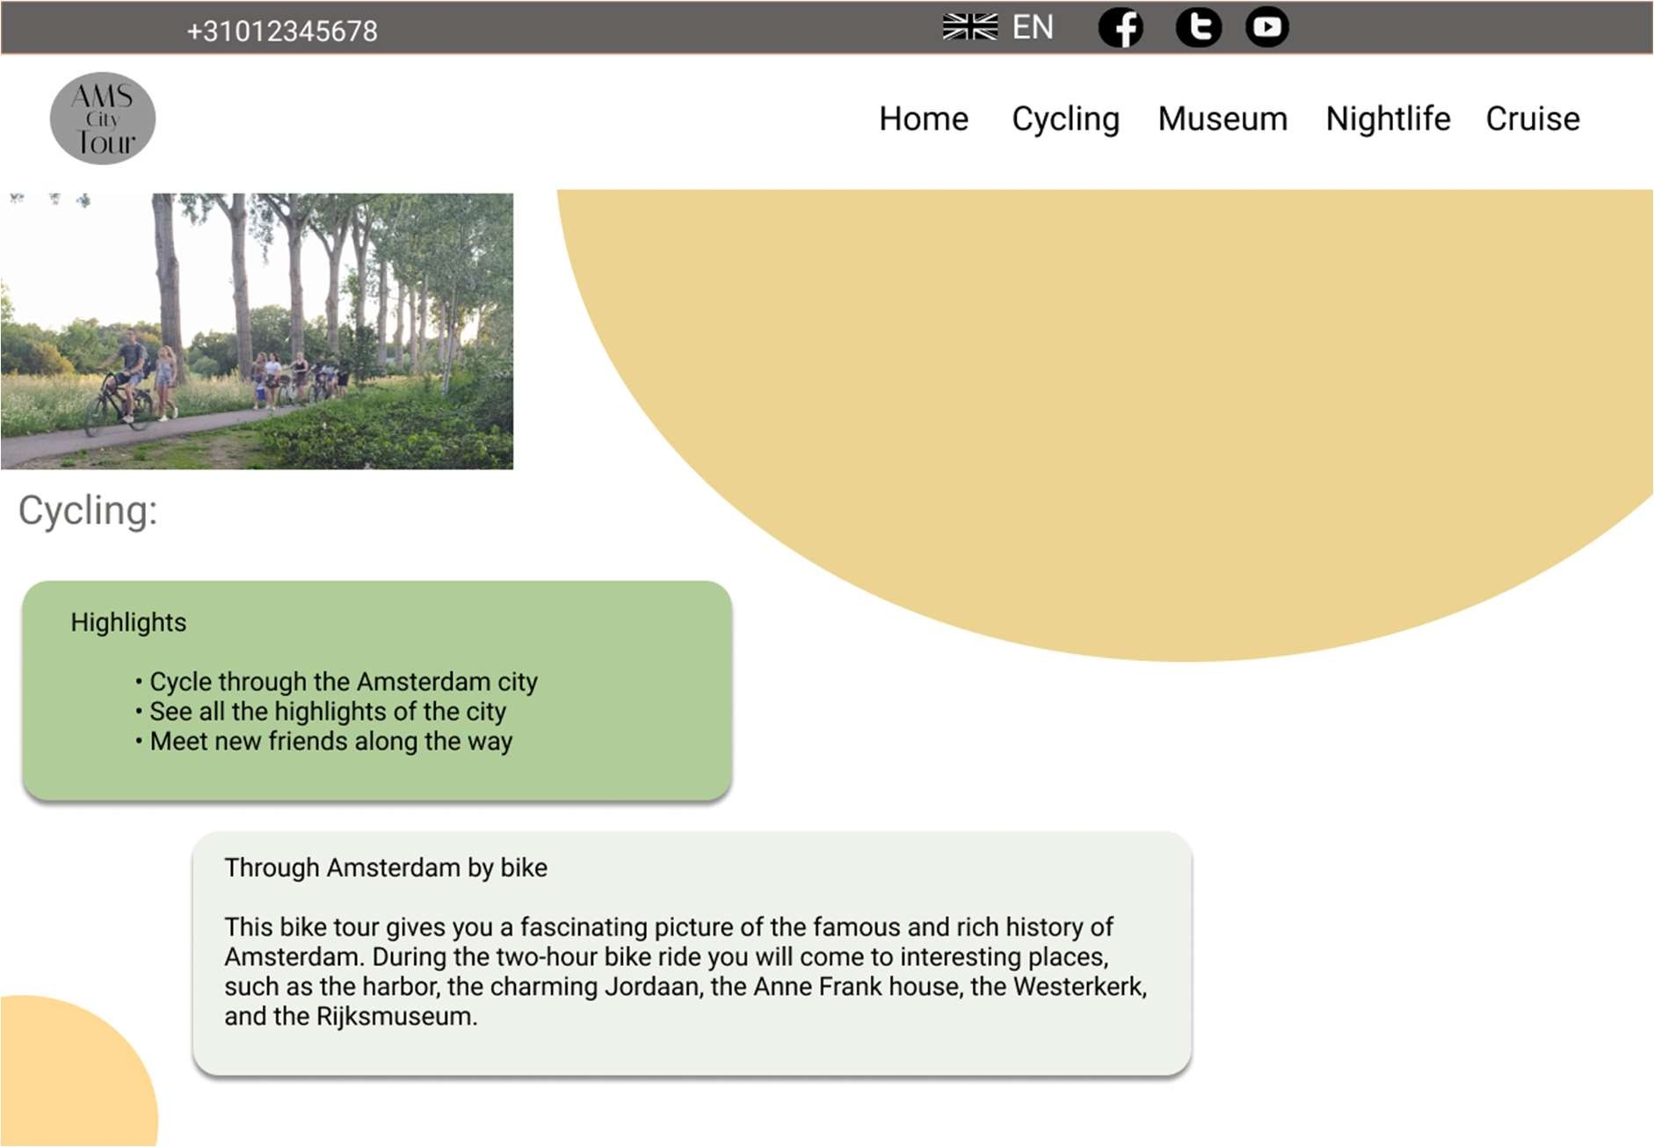

This is the second details page of my website. When you will click on museum then it will take you in this page

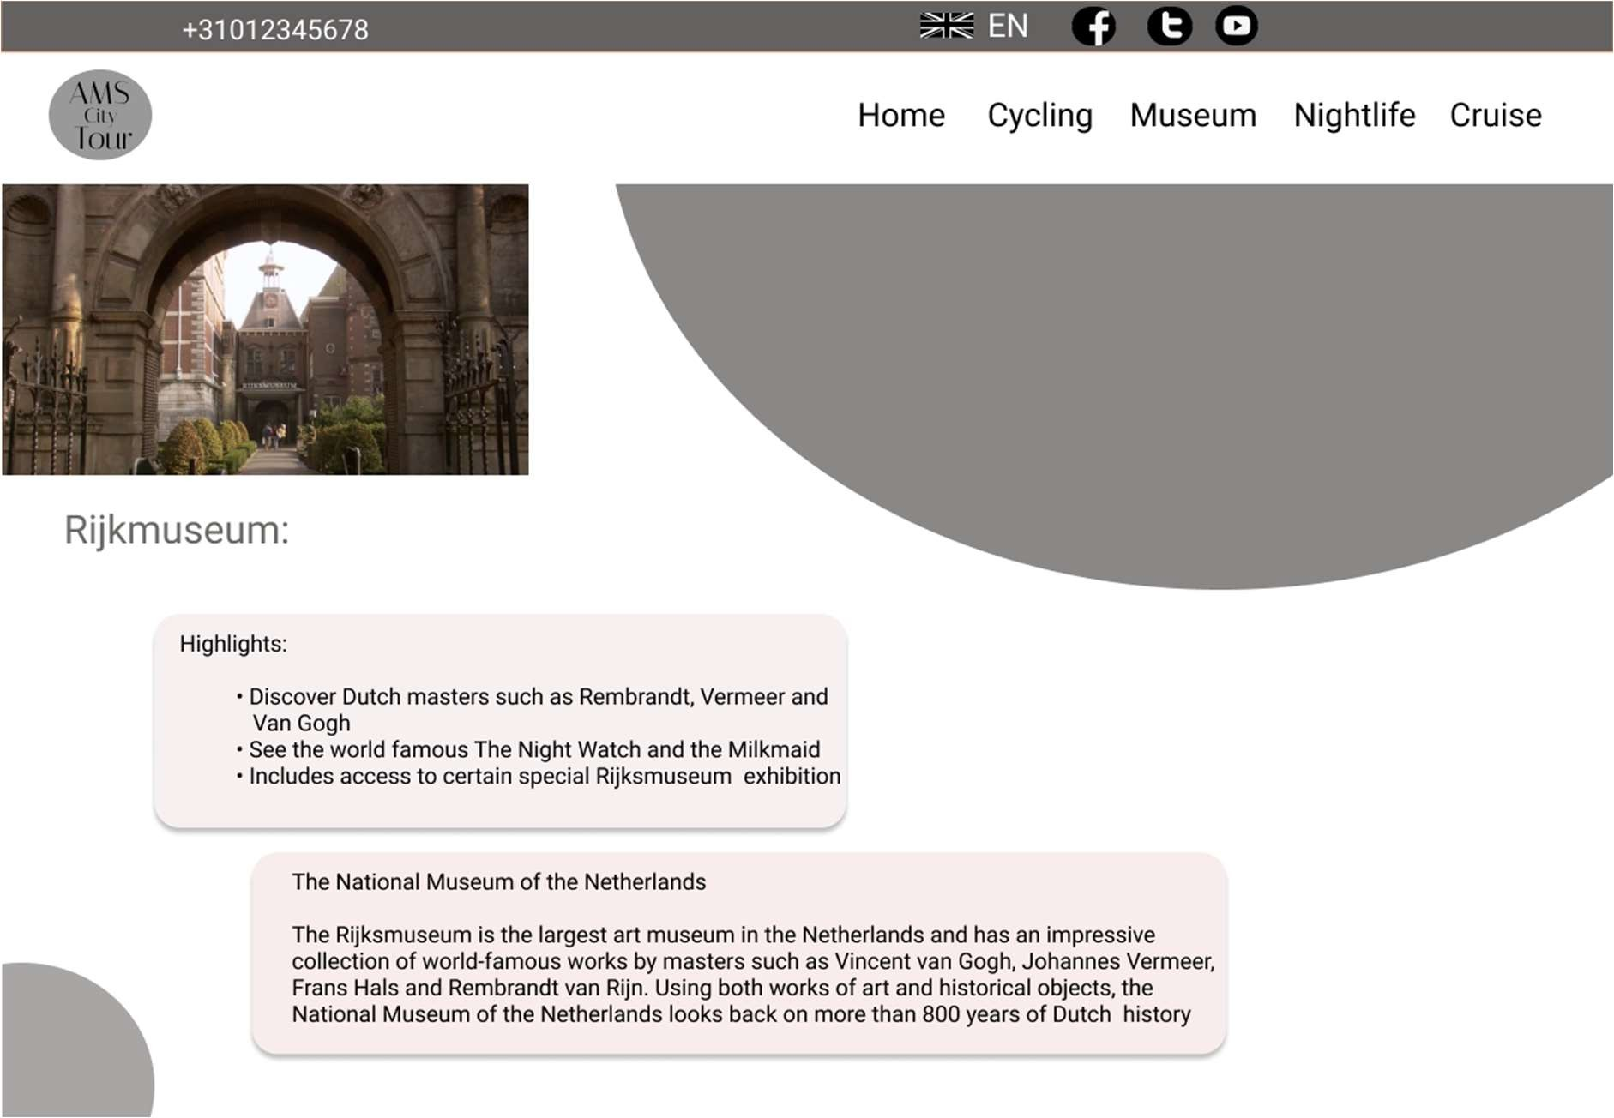

This is the third details page of my website. When you will click on nightlife then it will take you in this page

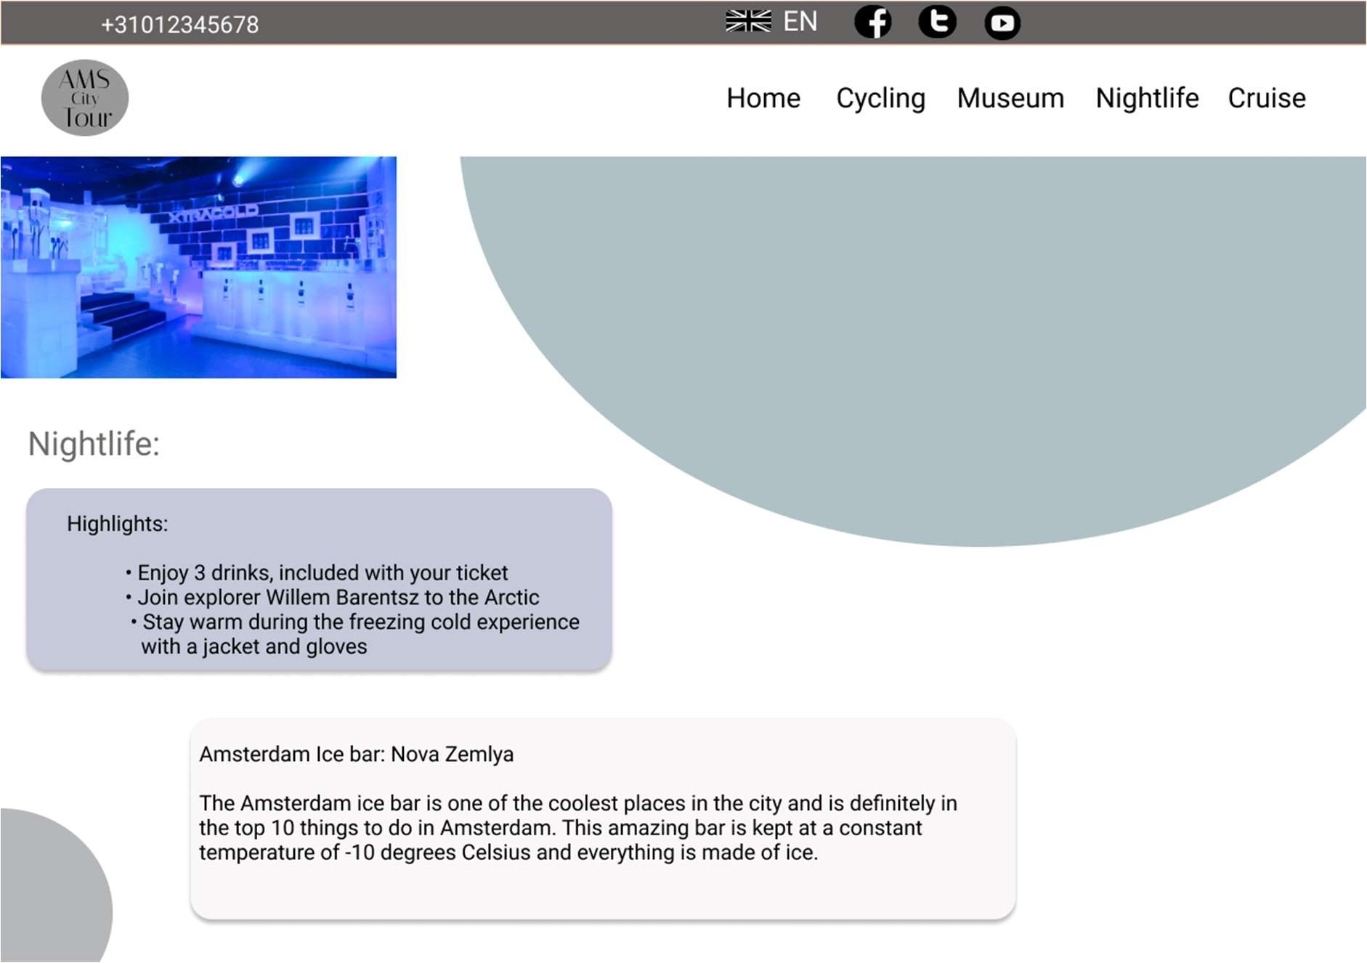

This is the fourth details page of my website. When you will click on cruise then it will take you in this page

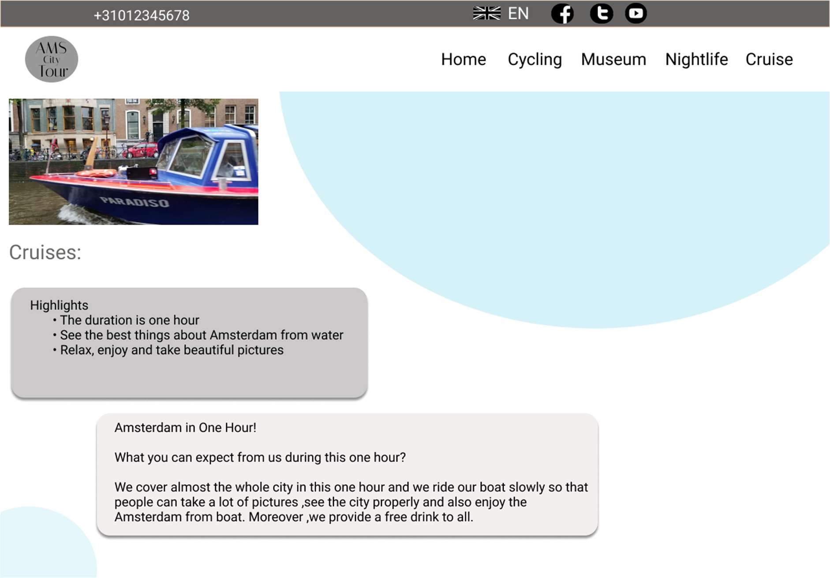

When You will click on contact us then it will take you in that page where you can send your messages to us by filling your details.

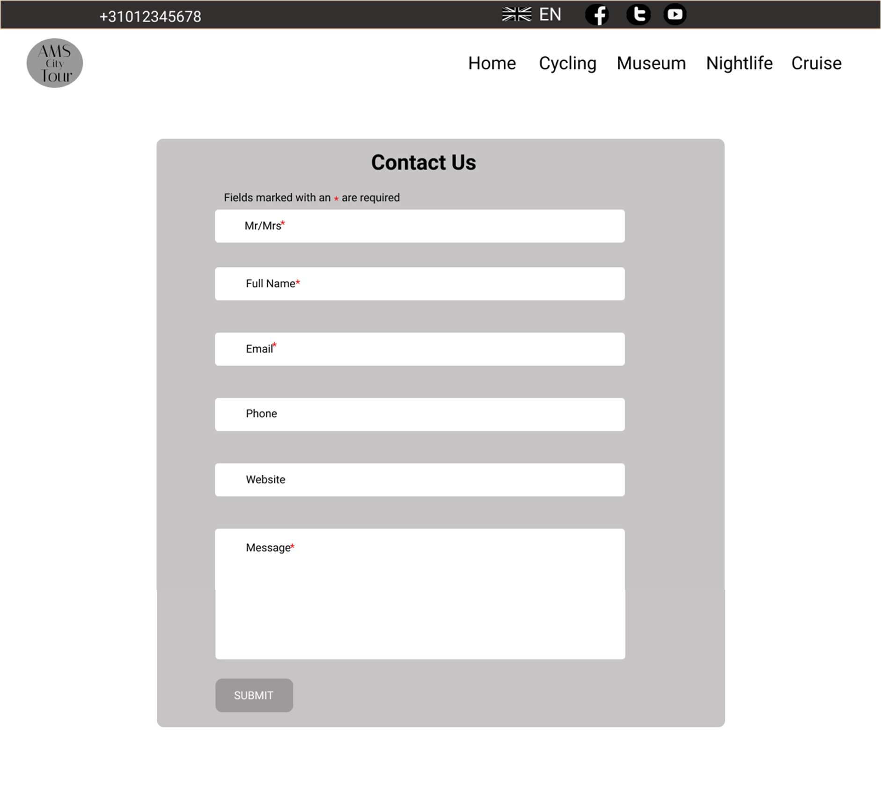

**This is for the tablet version**

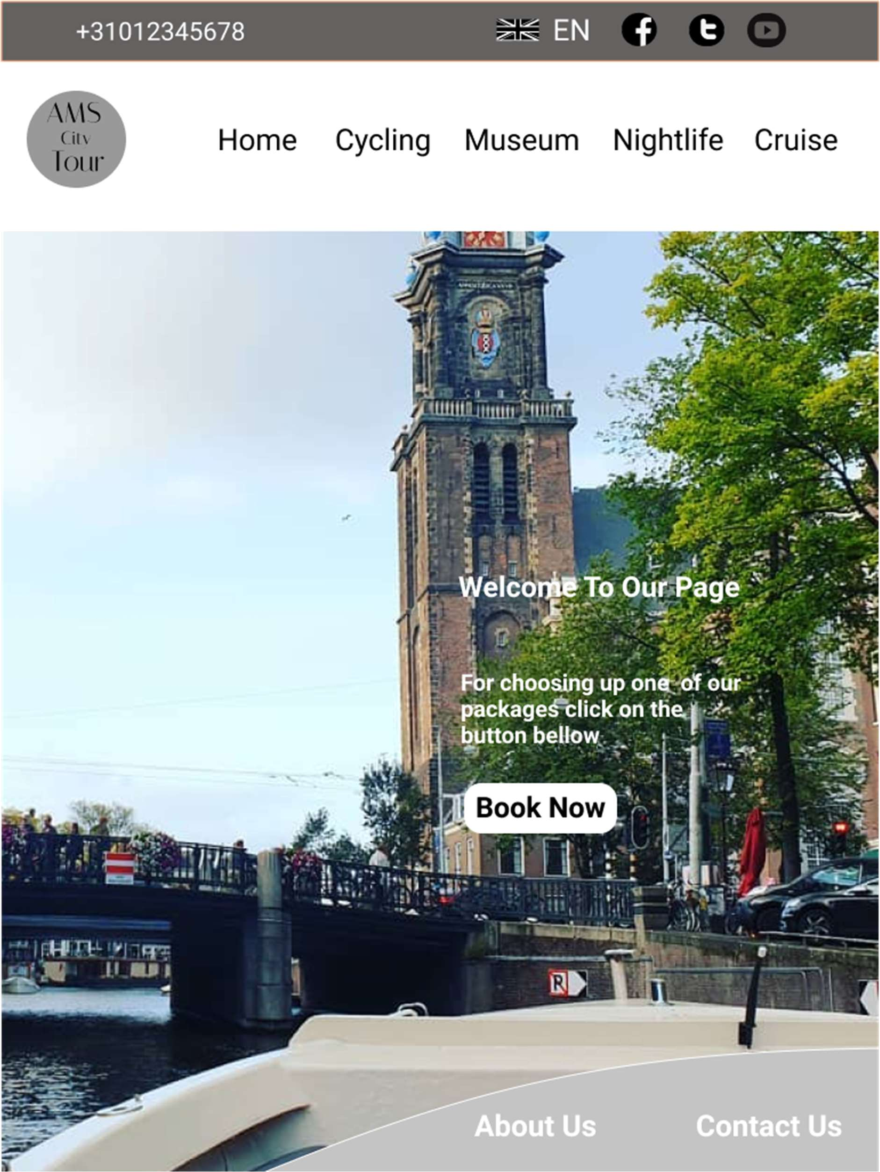

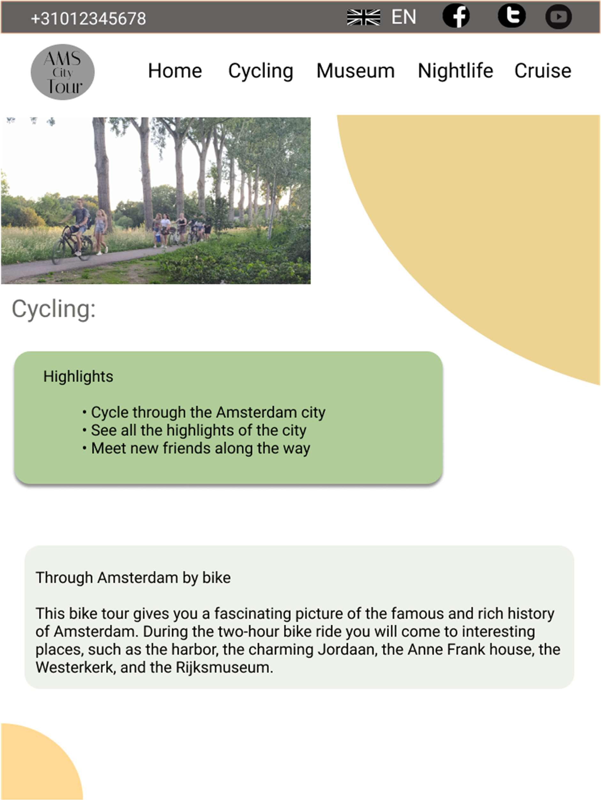

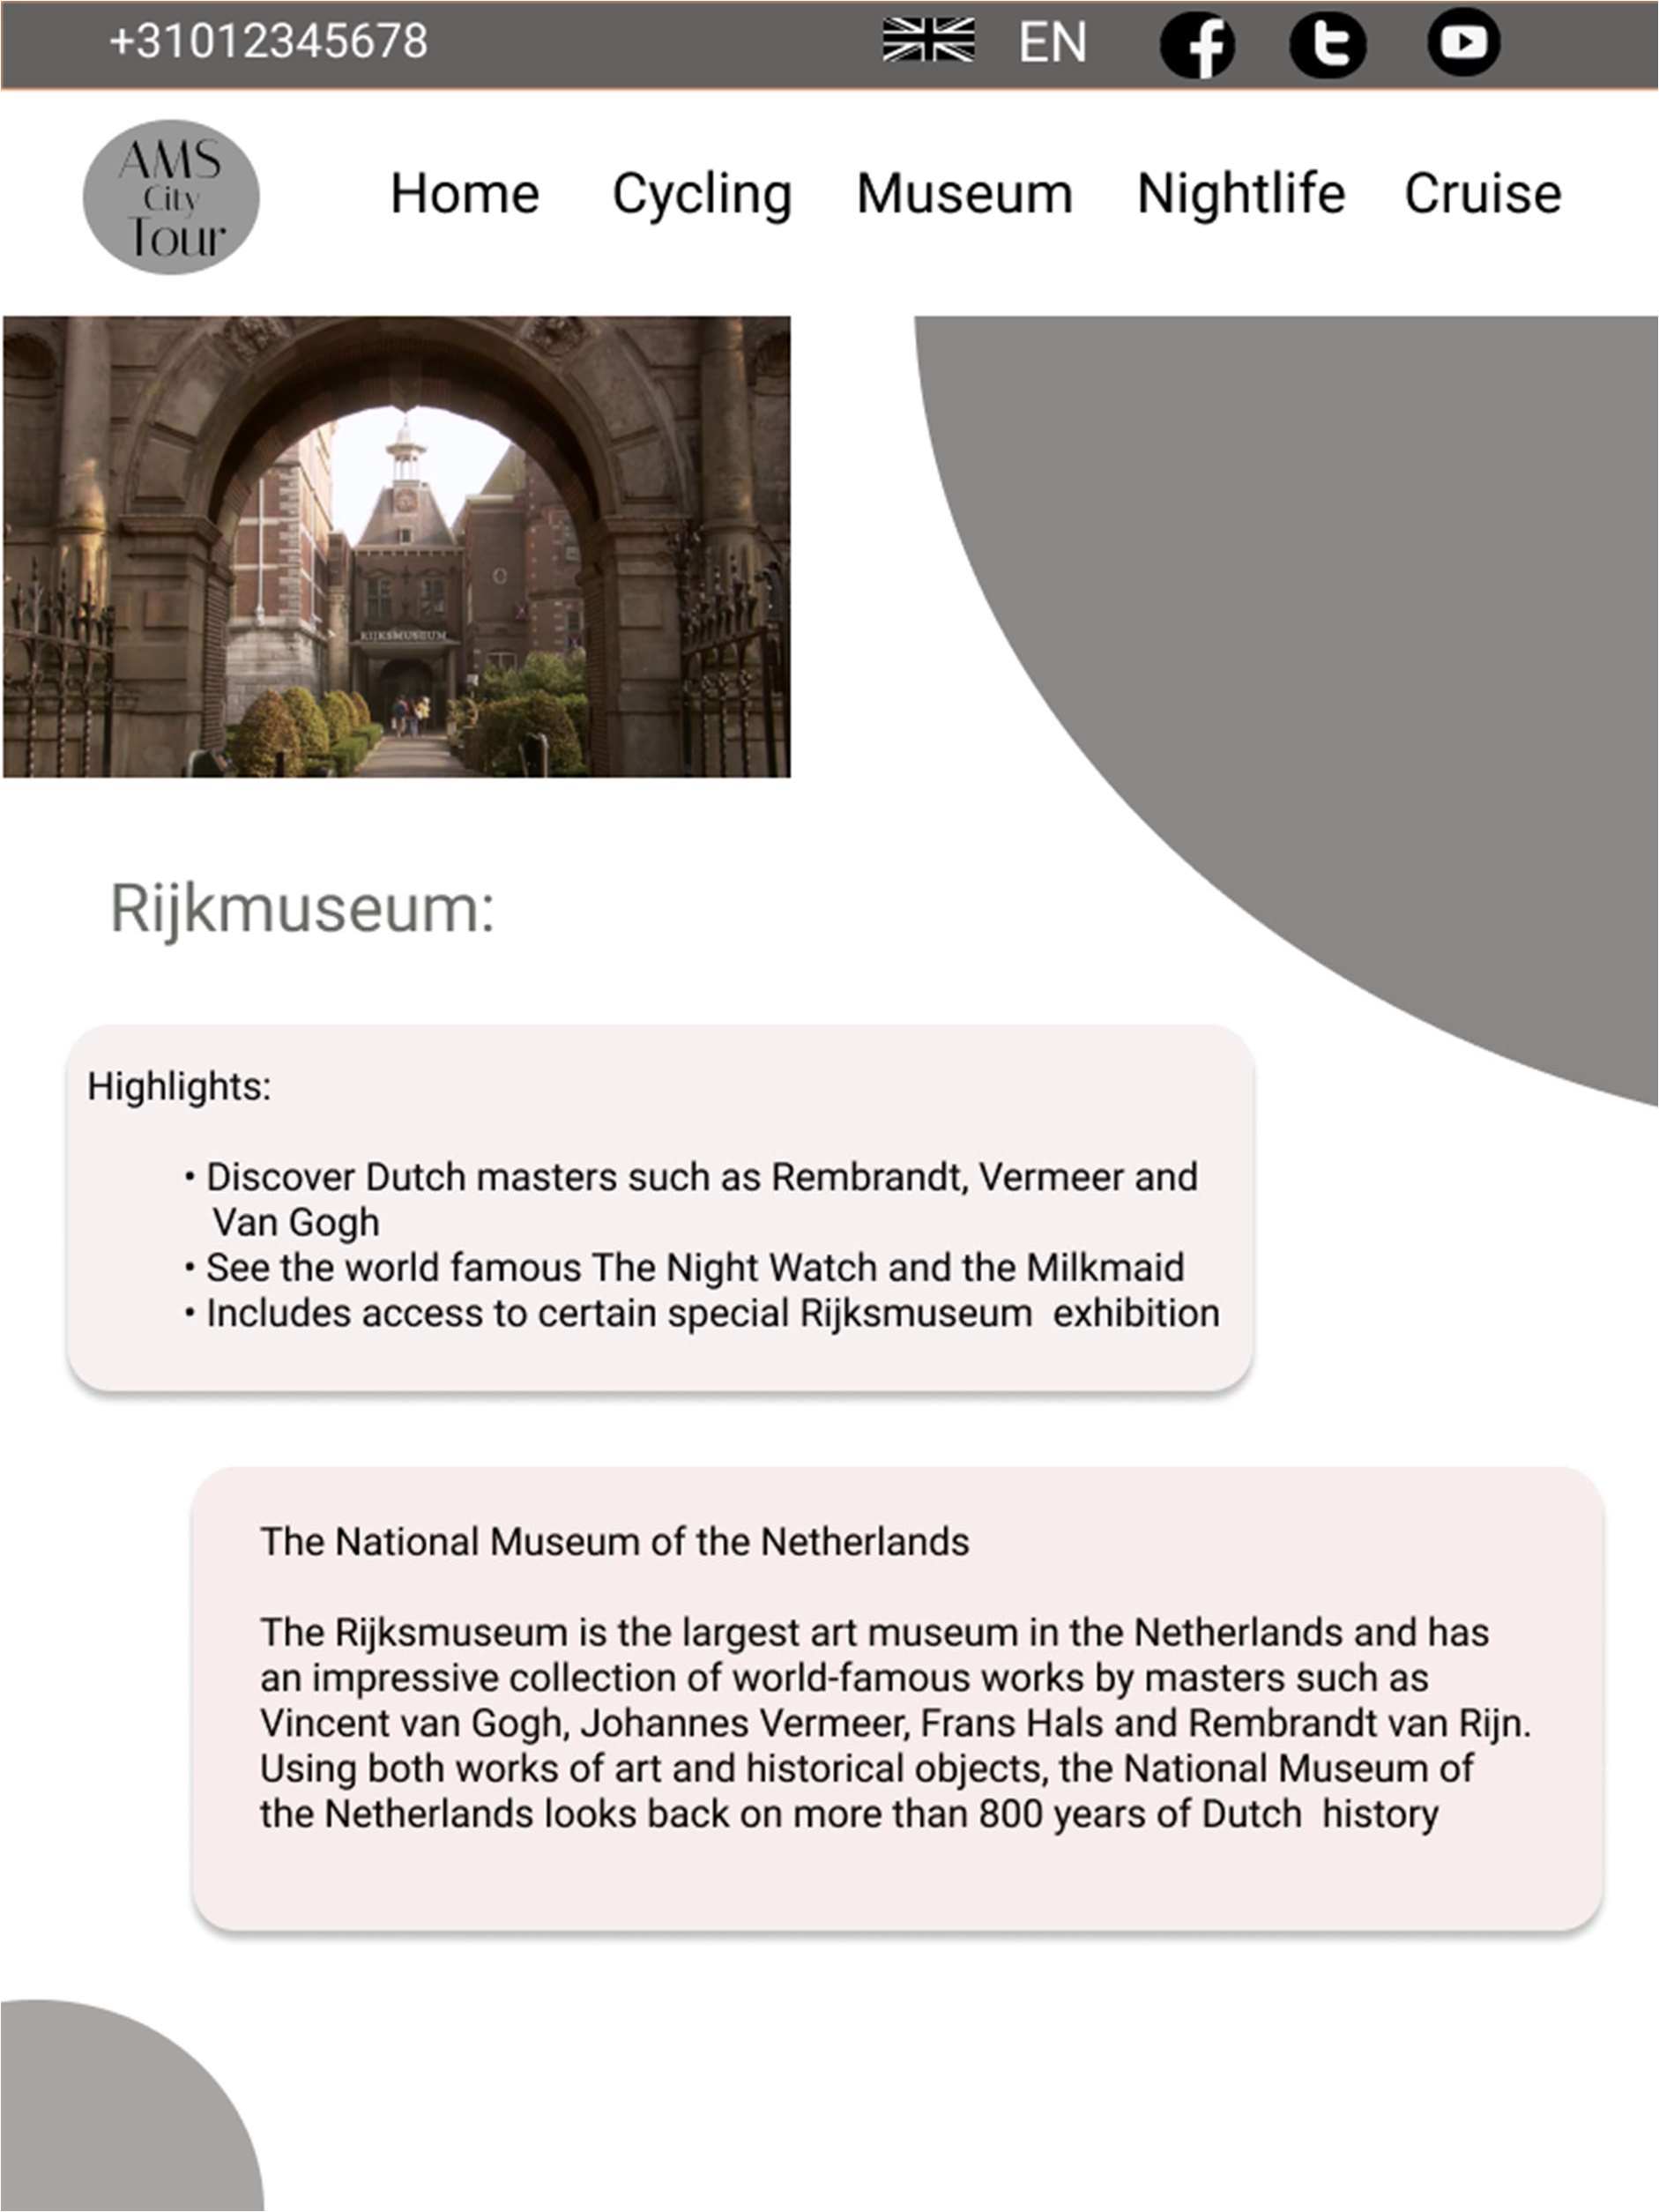

a

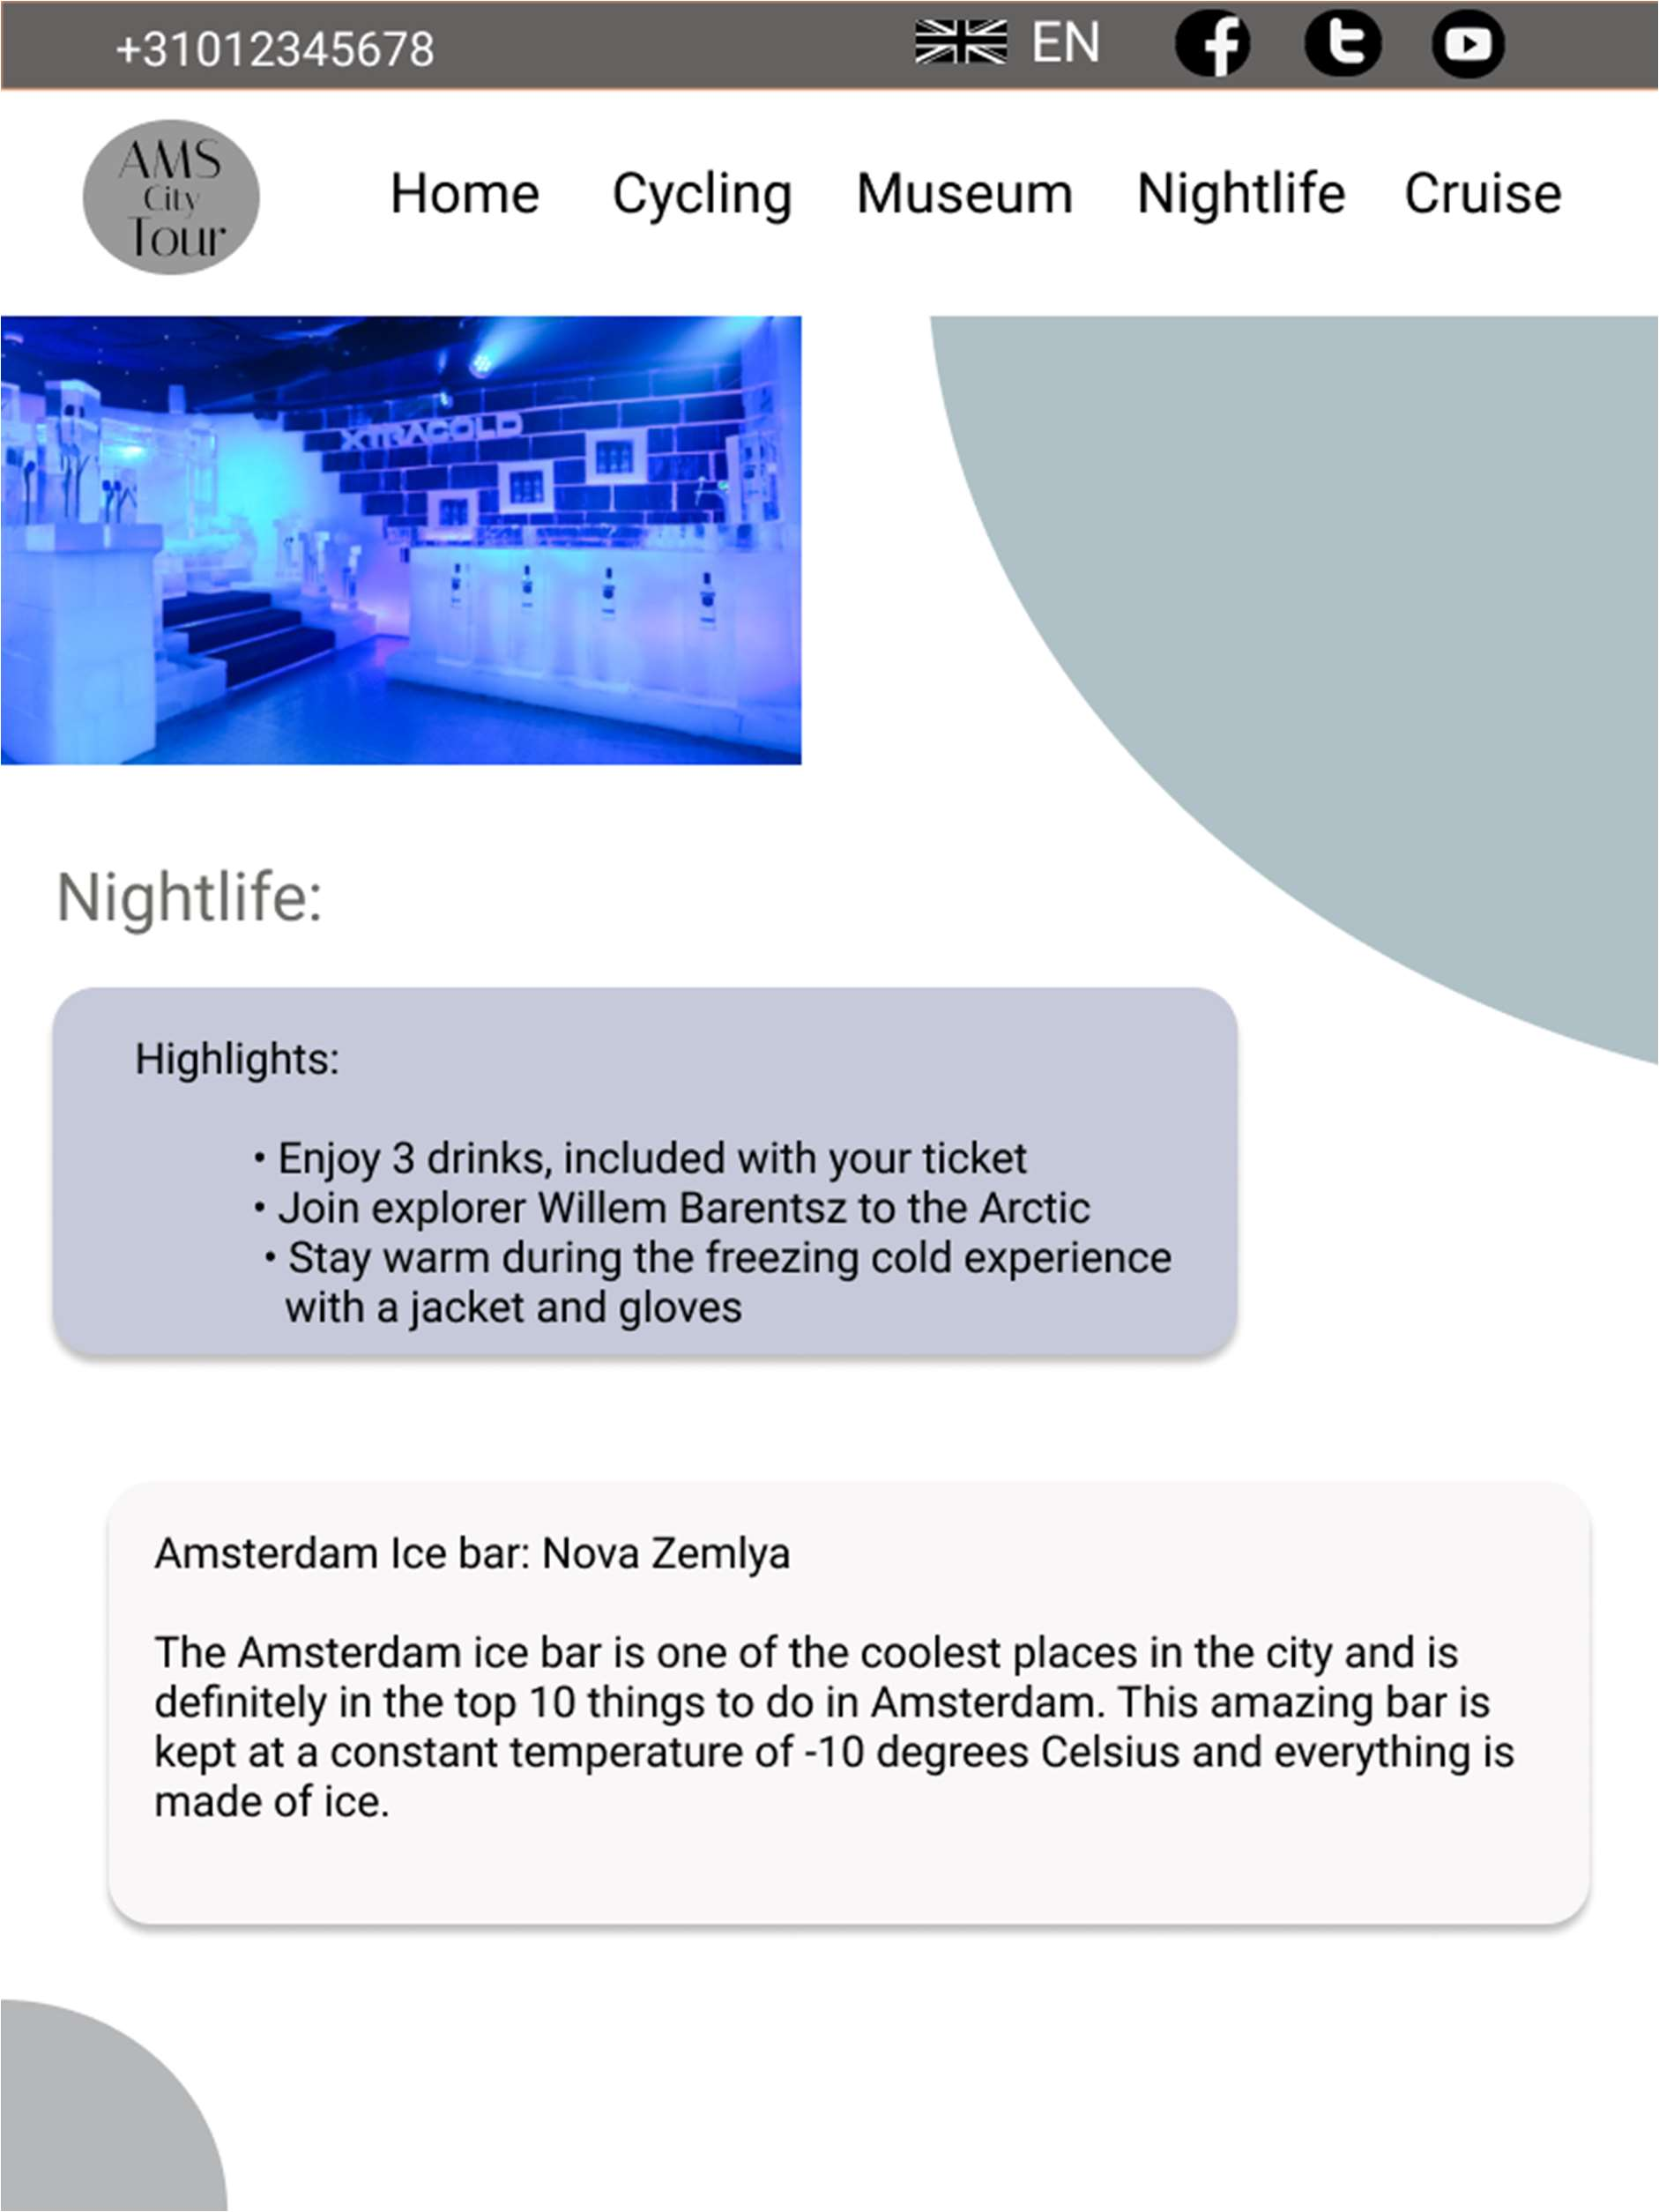

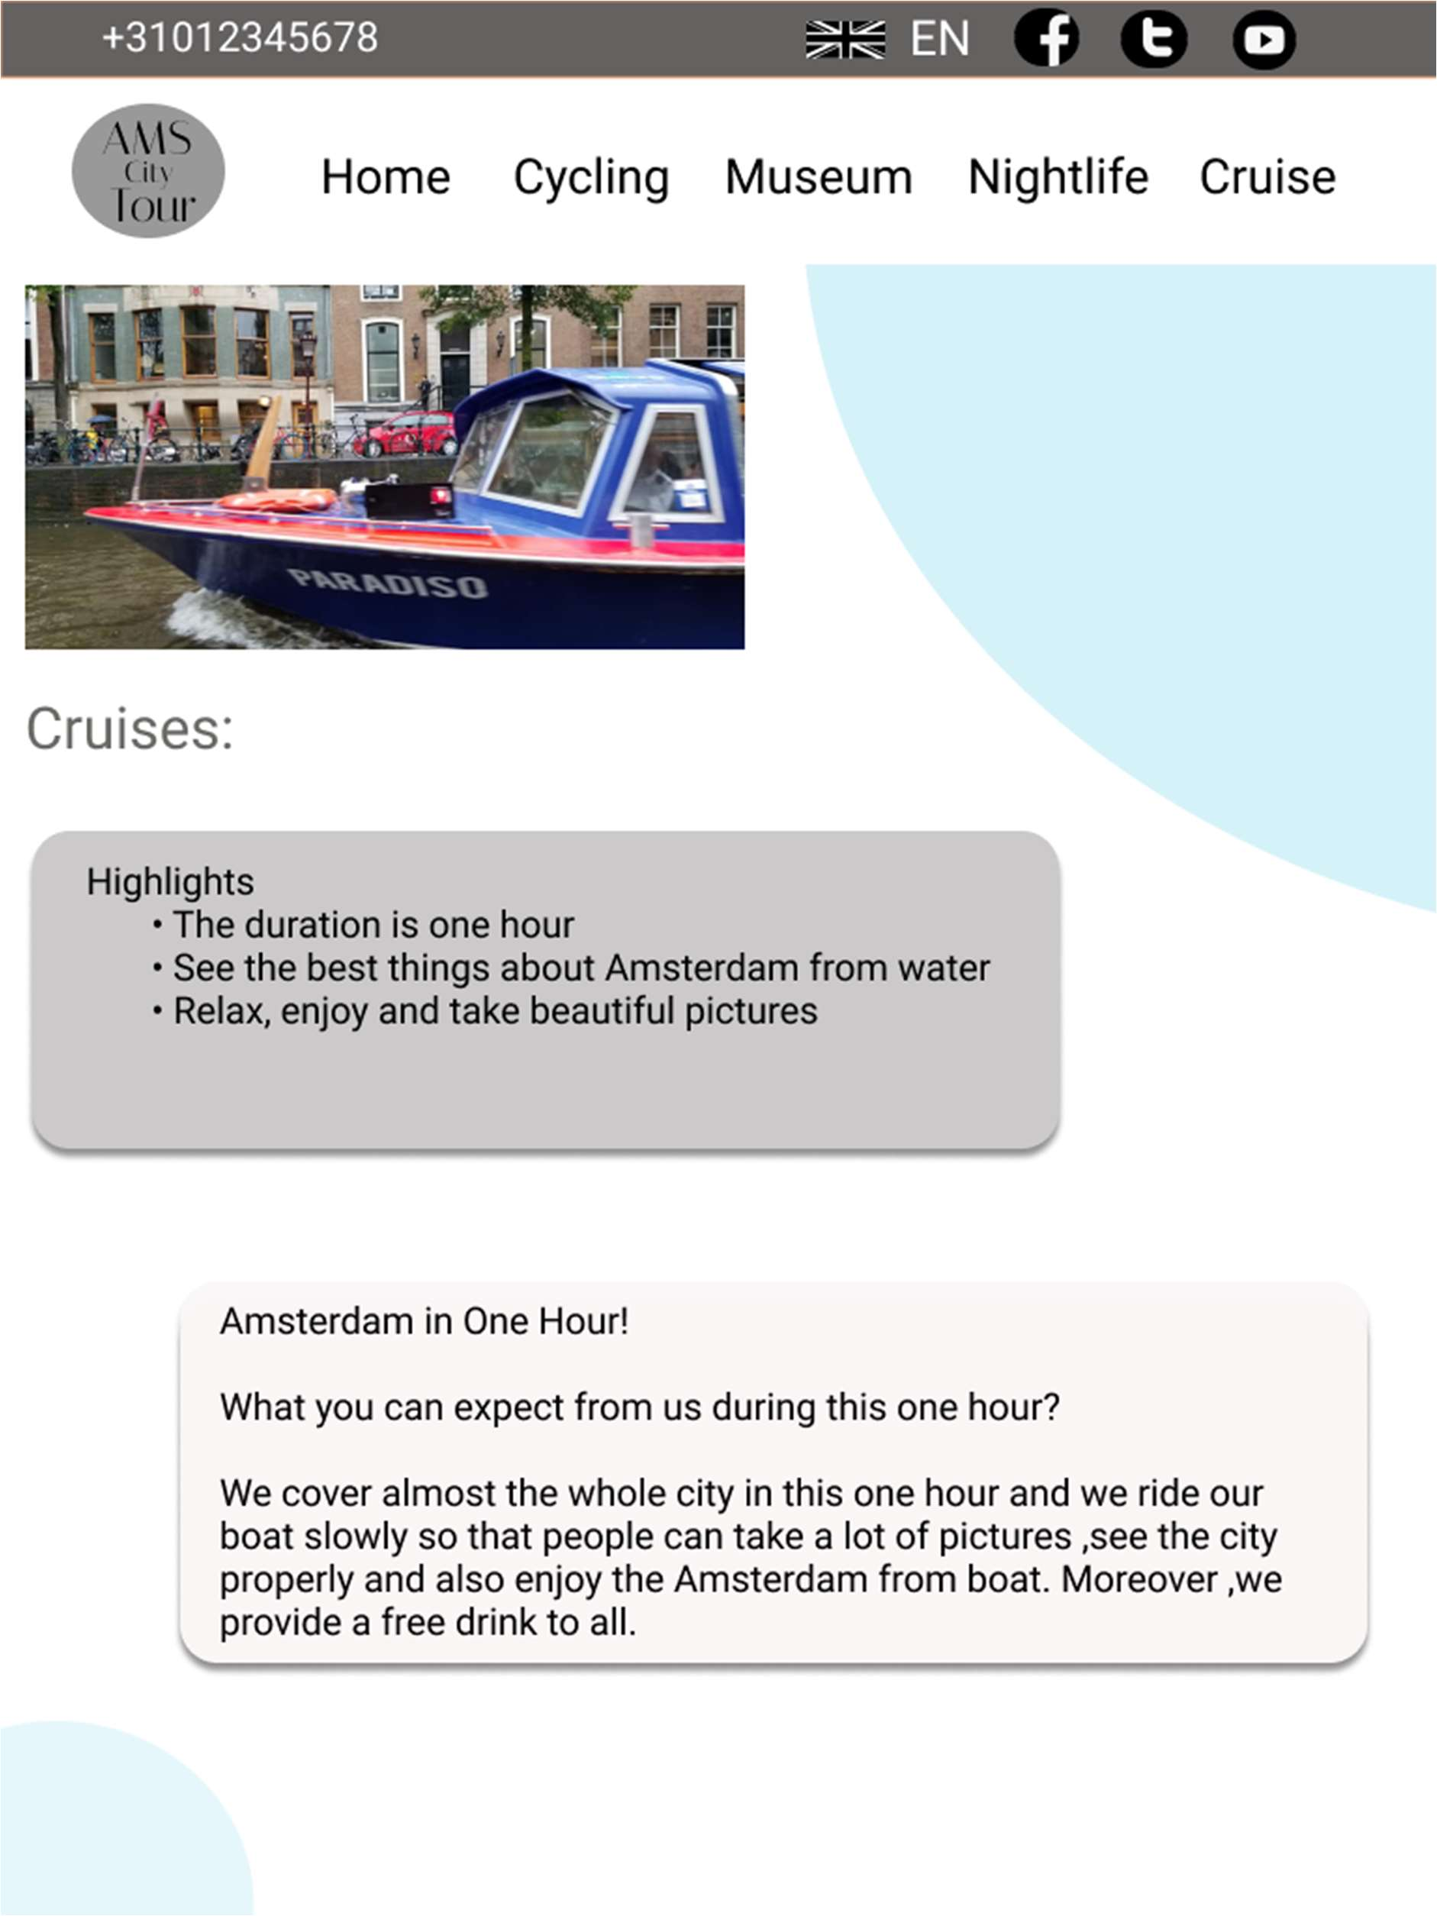

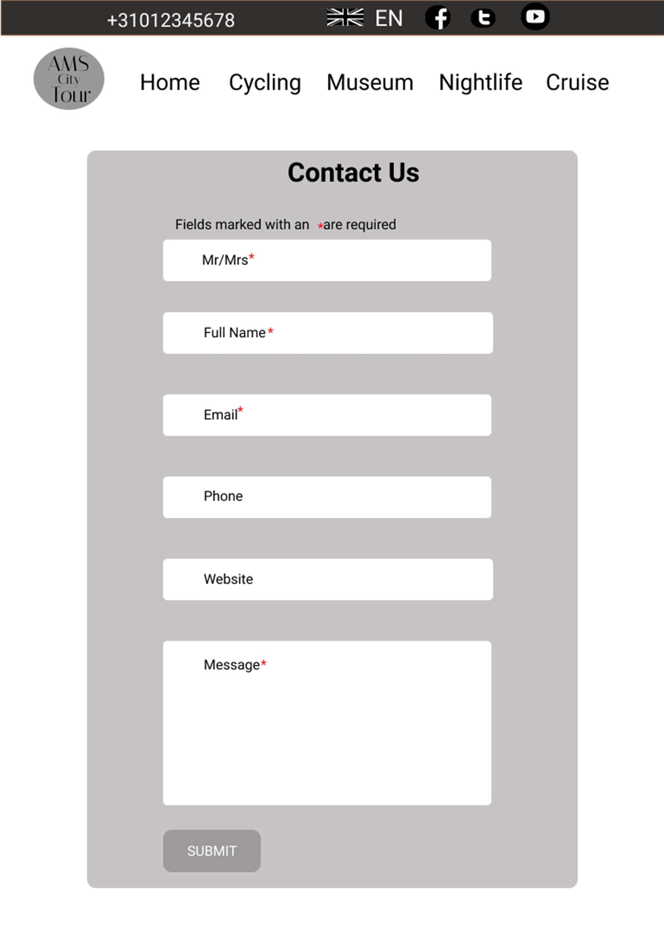

### Assignment 5 (Website Design Version 2) :

#### Date: 15-10-2021

Today, I updated my web design according to the feedback from the class. In version 1 , “where am I ” wasn’t designed properly .But today I updated it . Also, I added some payment information which was forbidden, and I remove it today. Moreover ,I didn’t finish my tablet version last week which I did today. Finally, I evaluate myself. Below I have attested all my today’s work.

# Desktop Version:

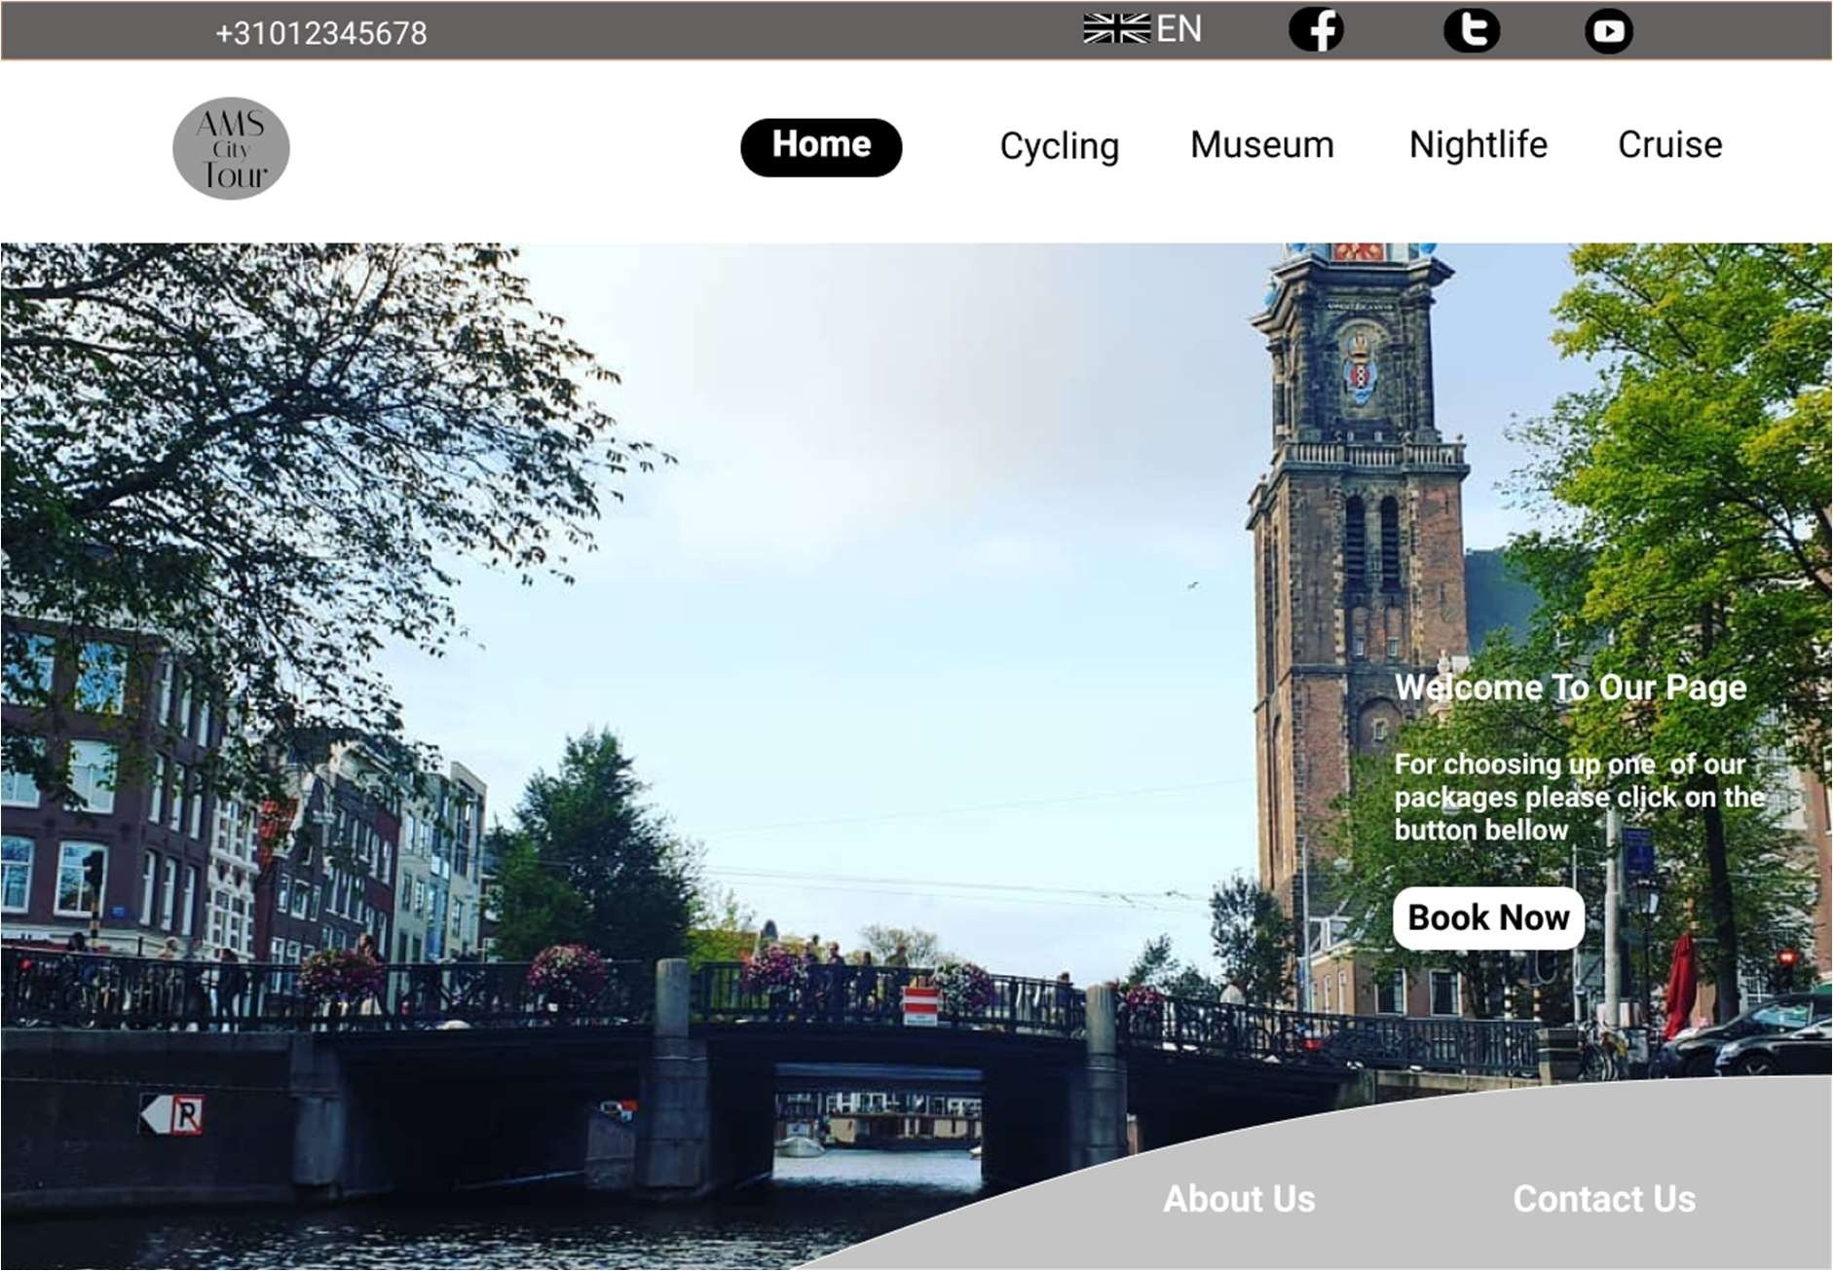

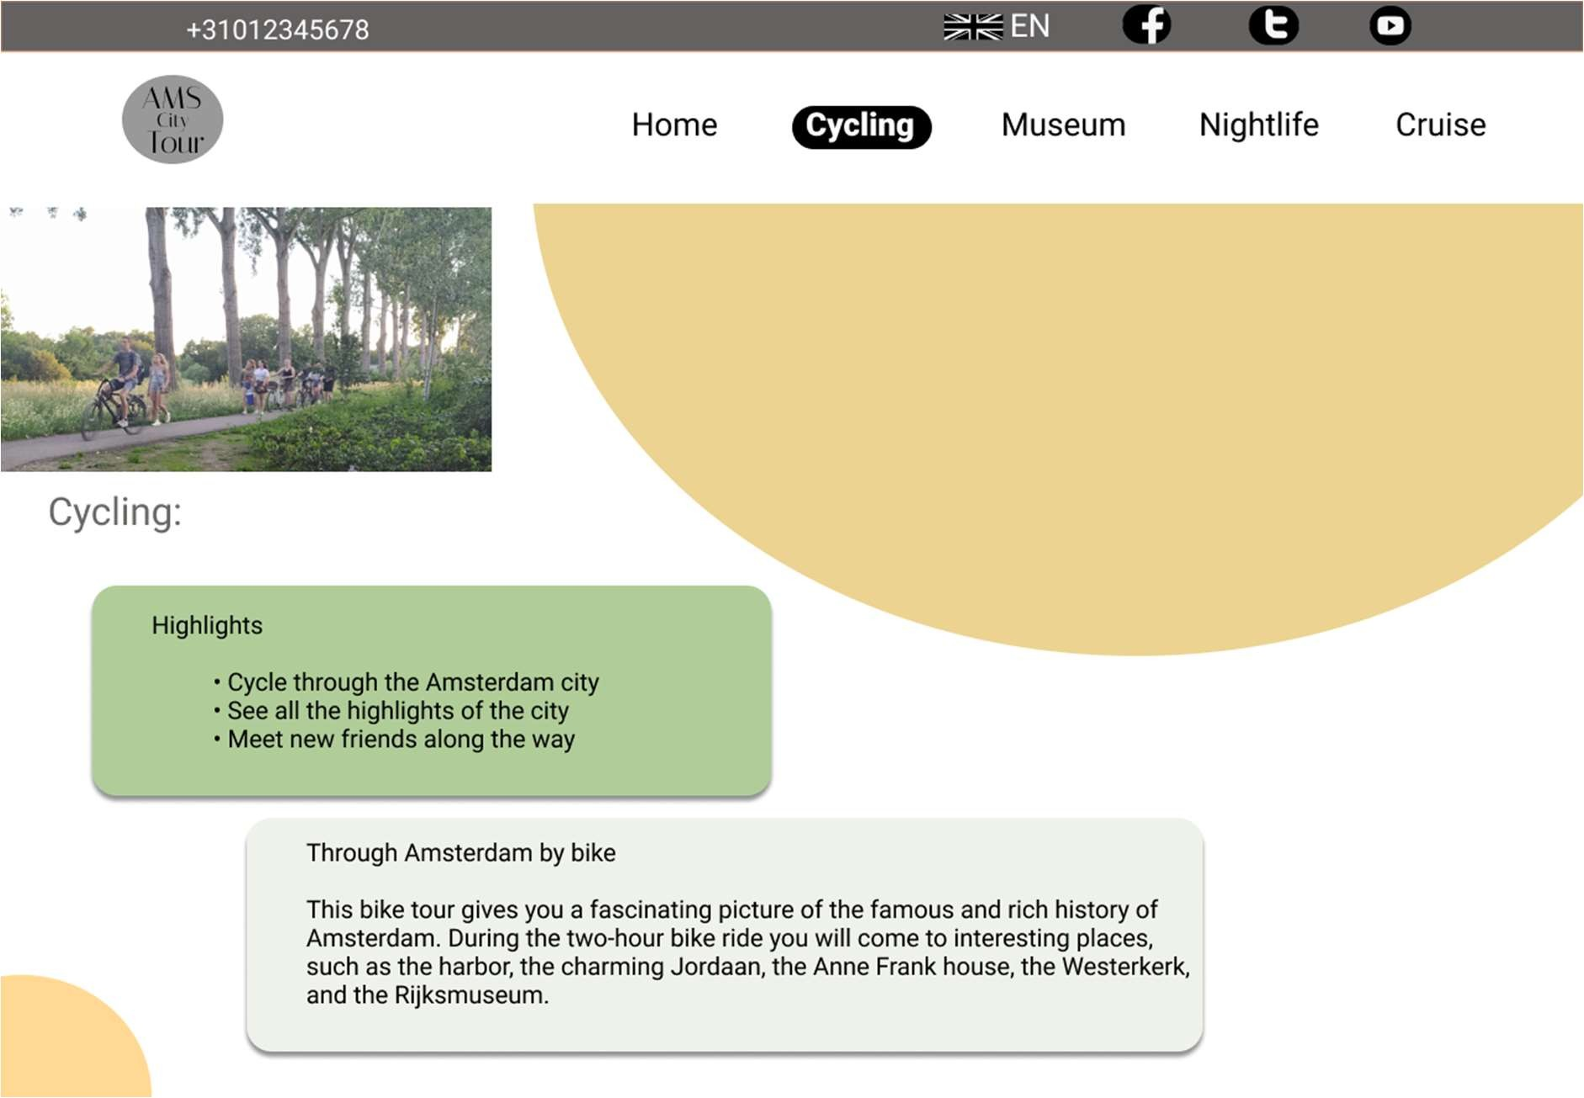

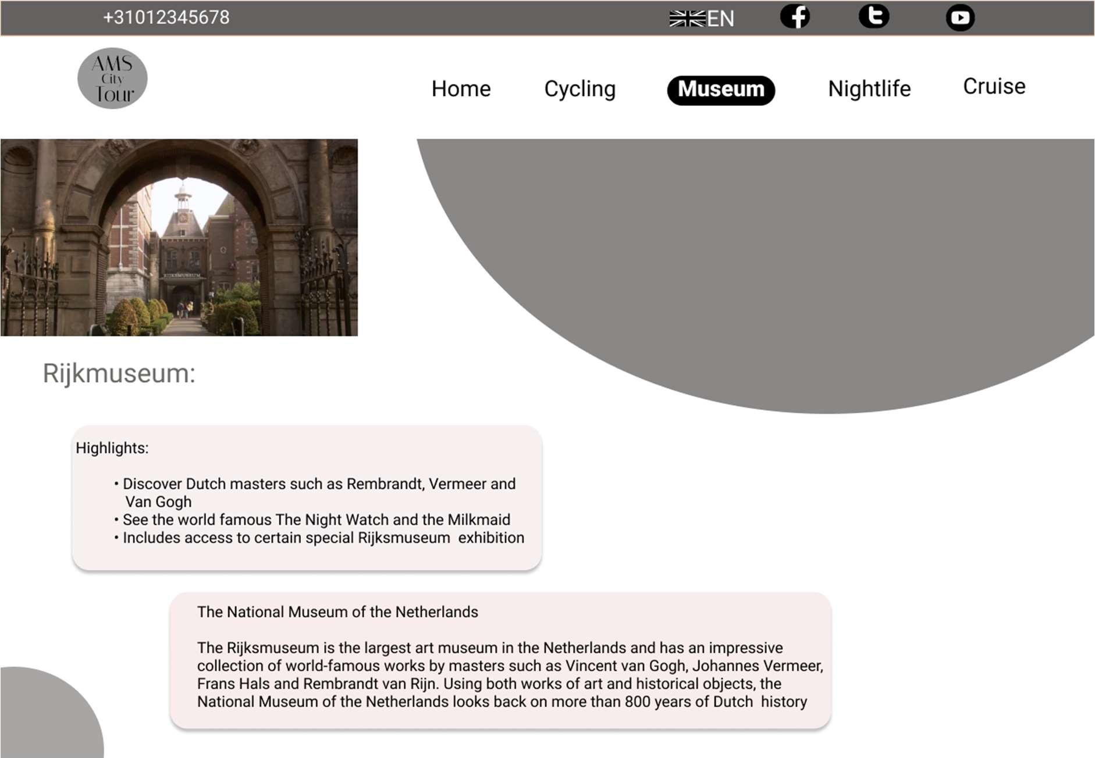

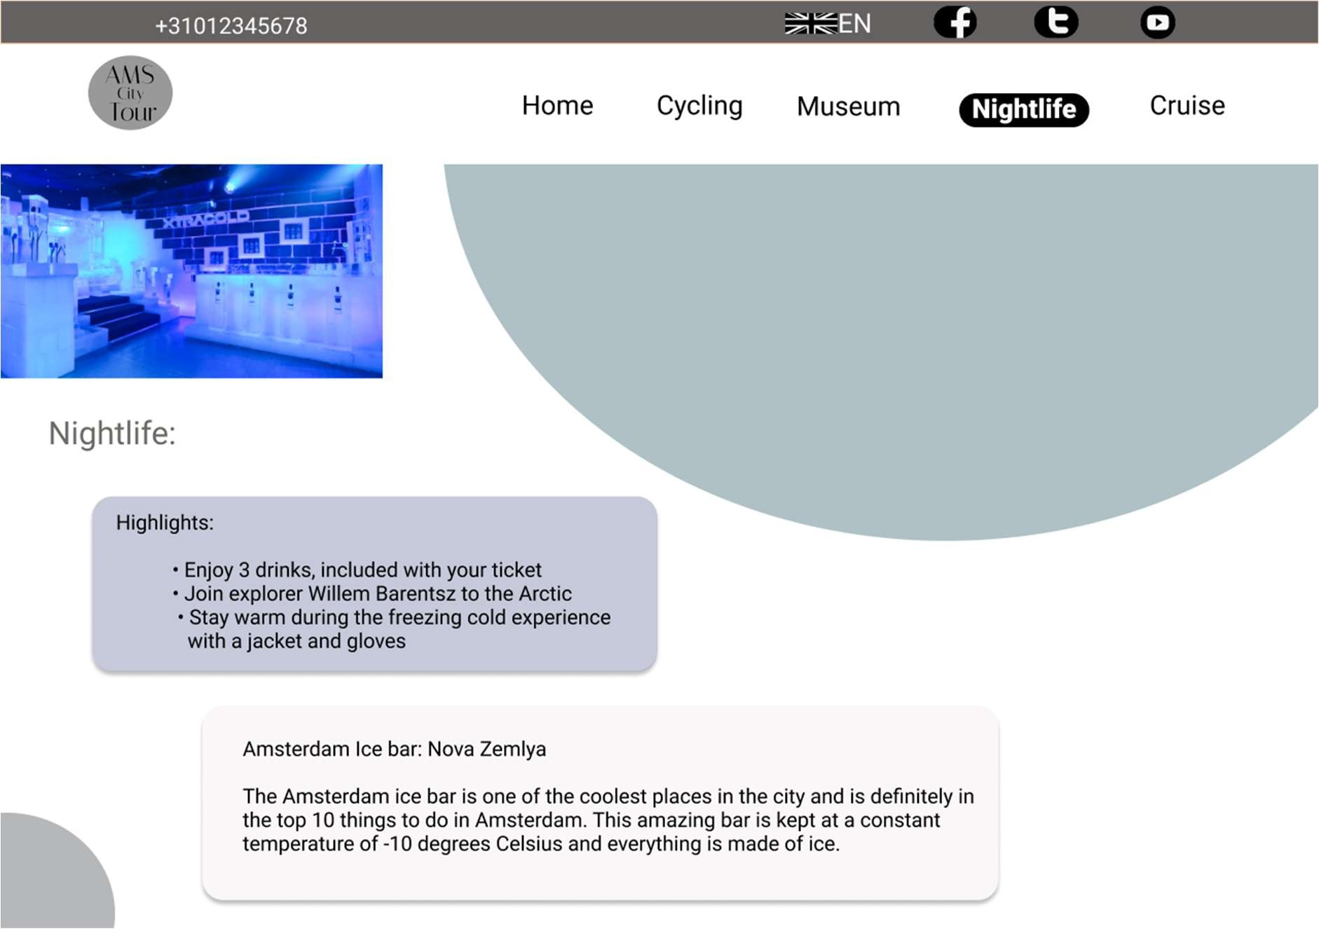

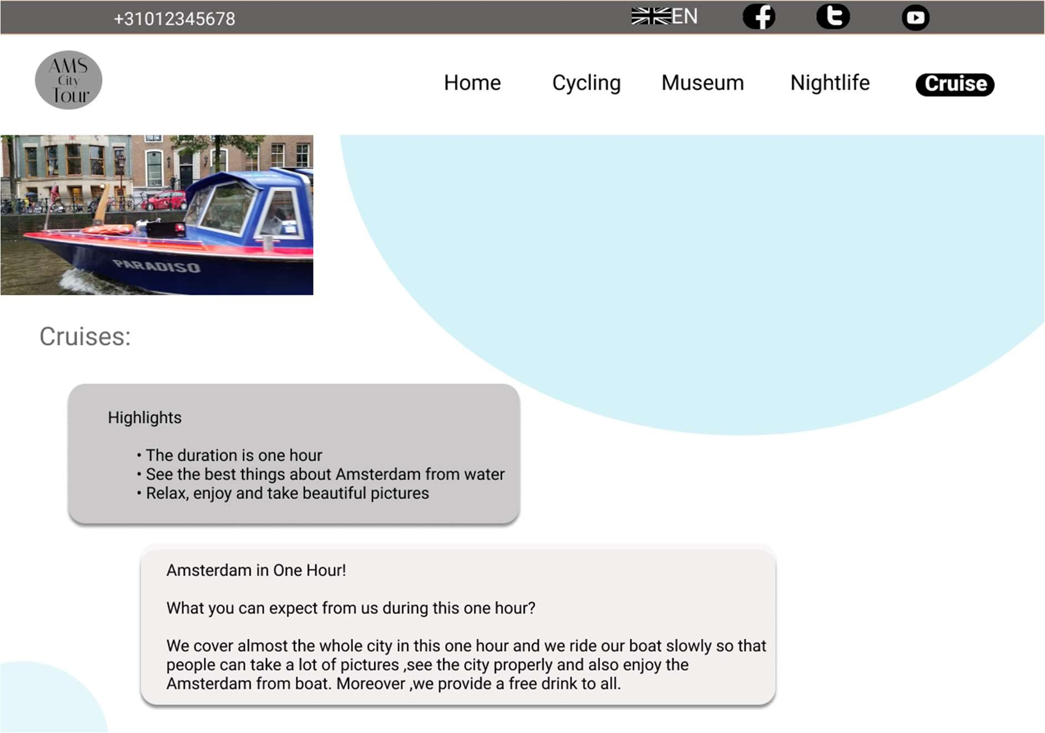

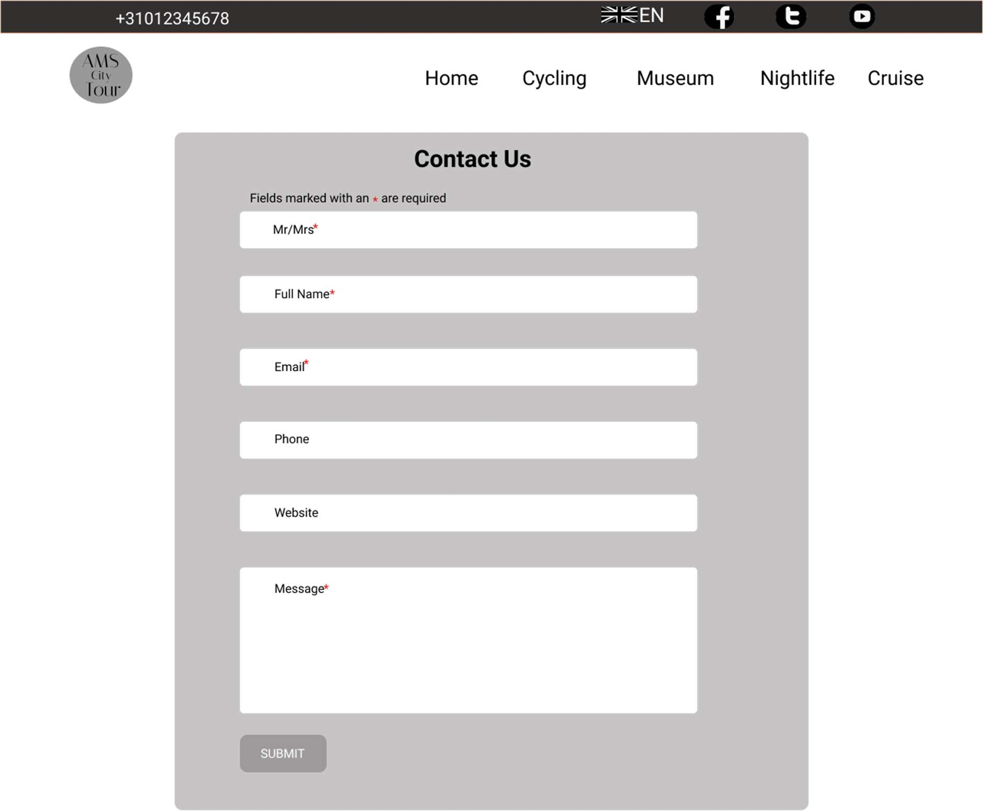

**iPad Version:**

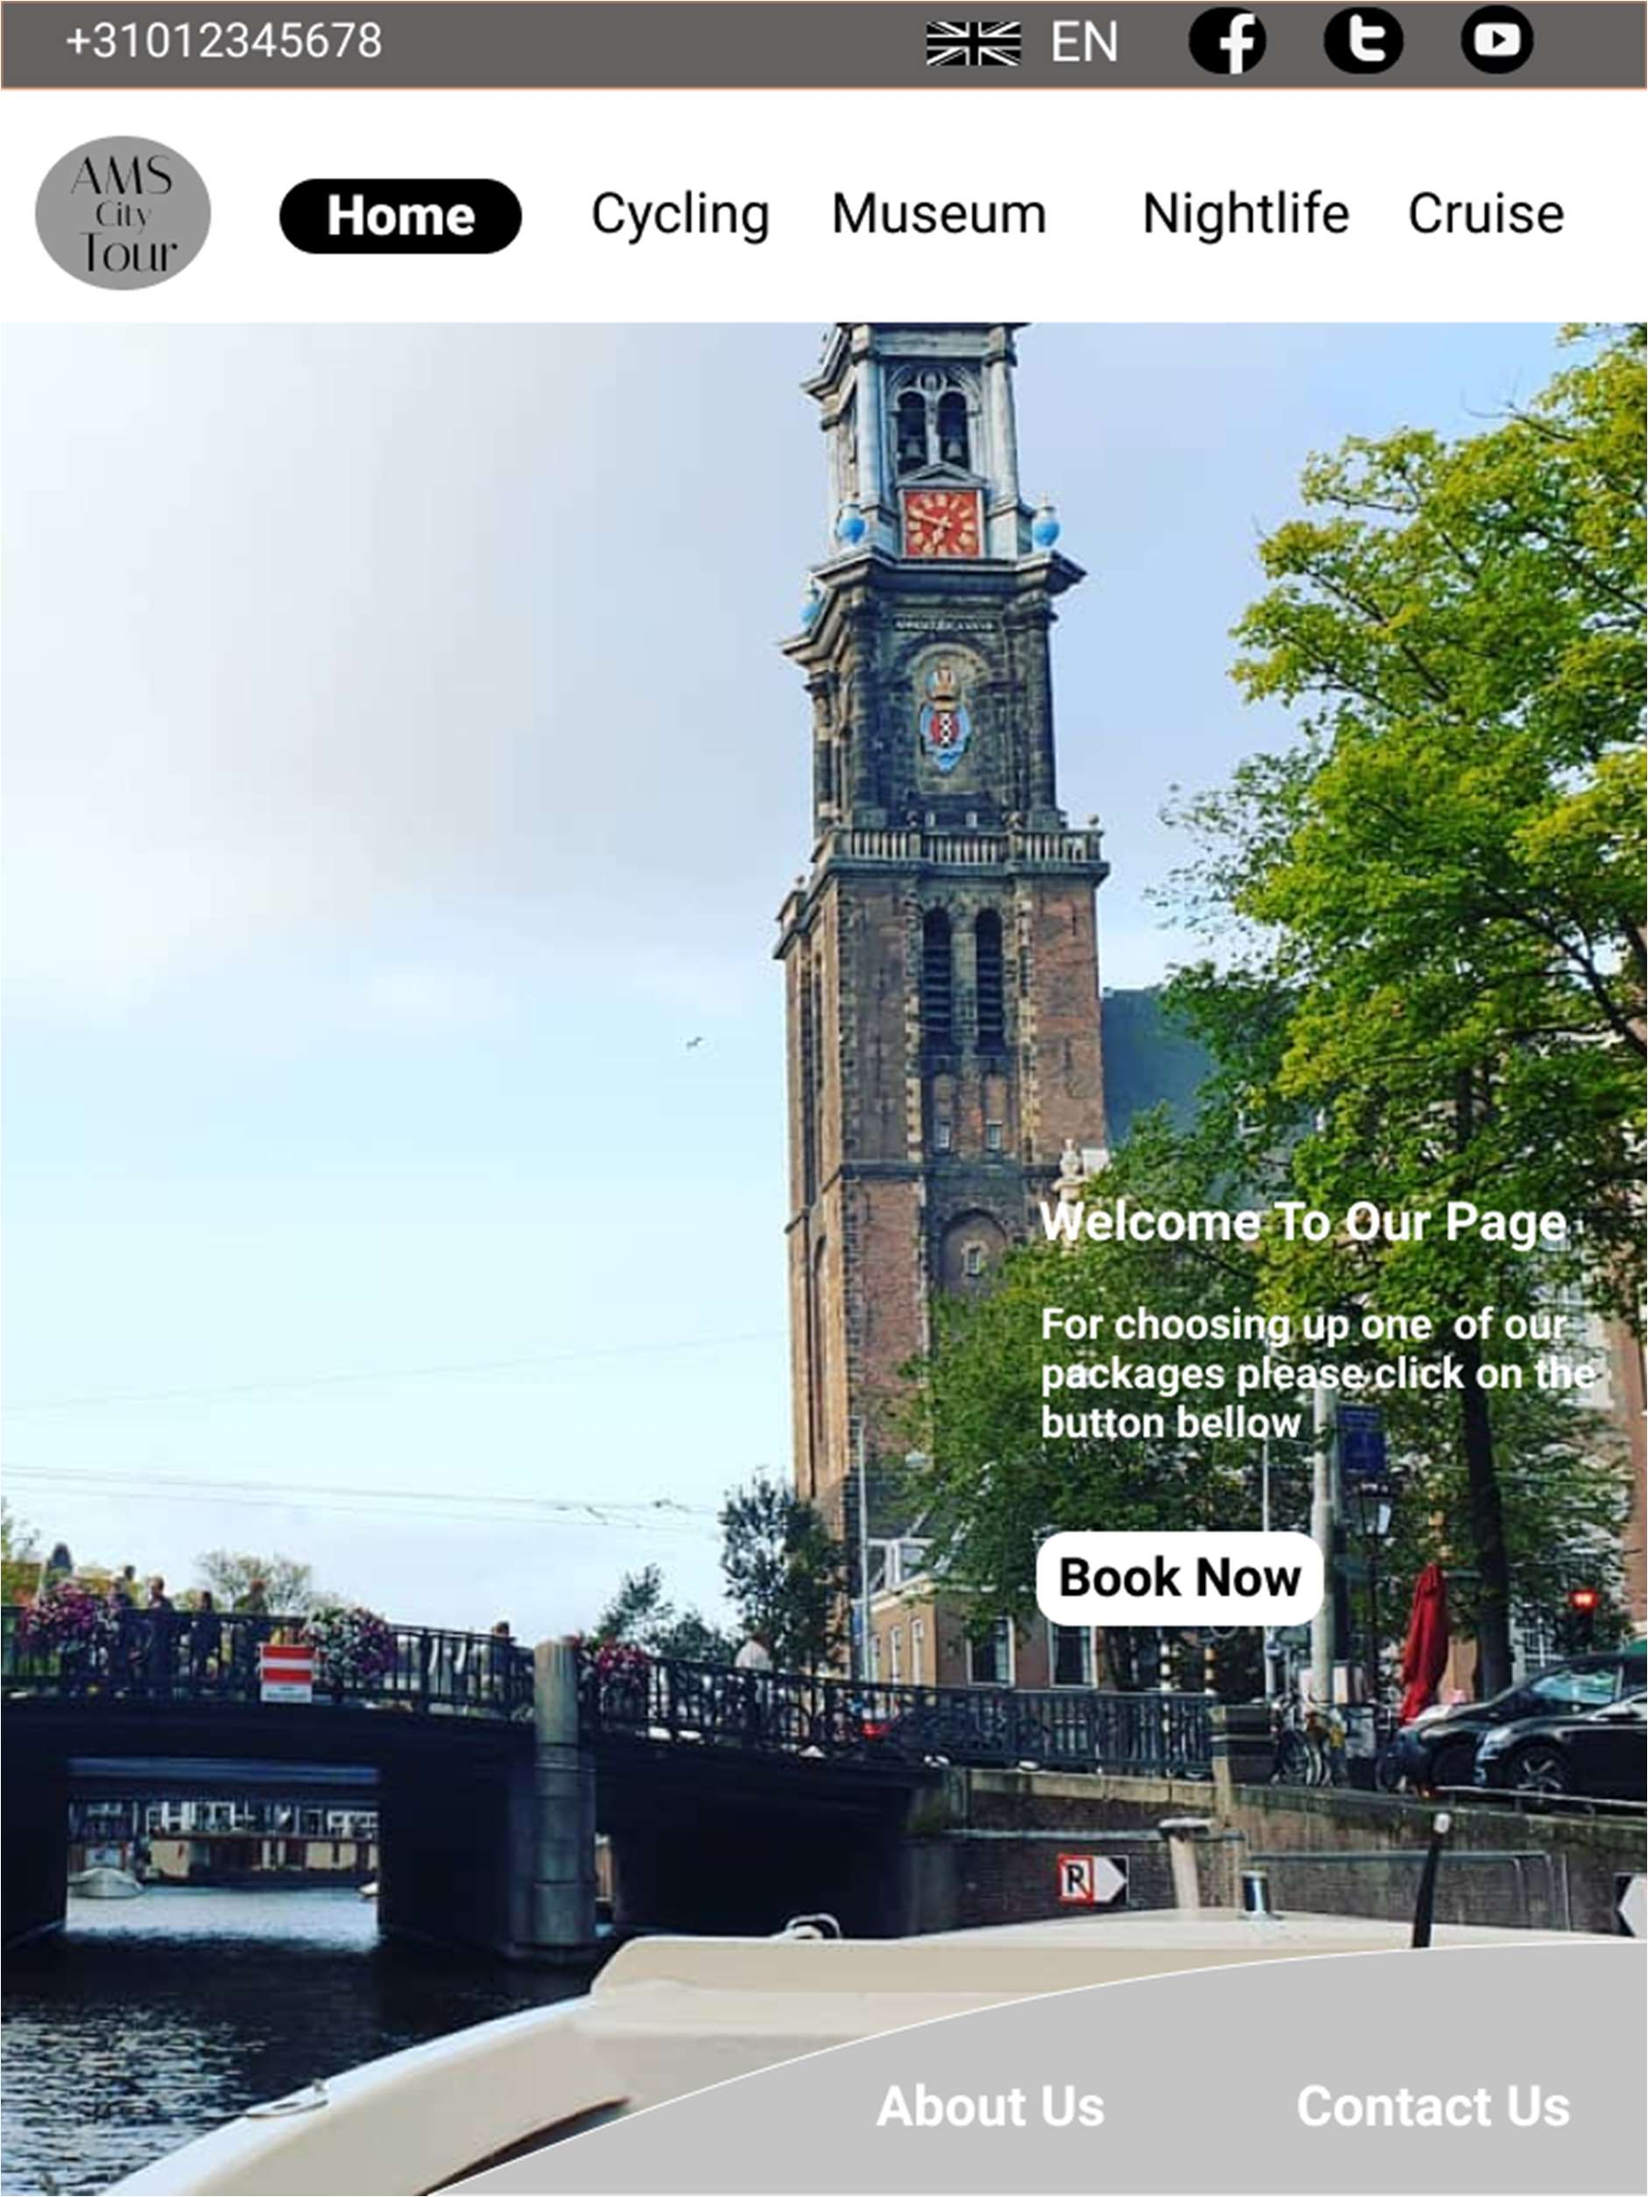

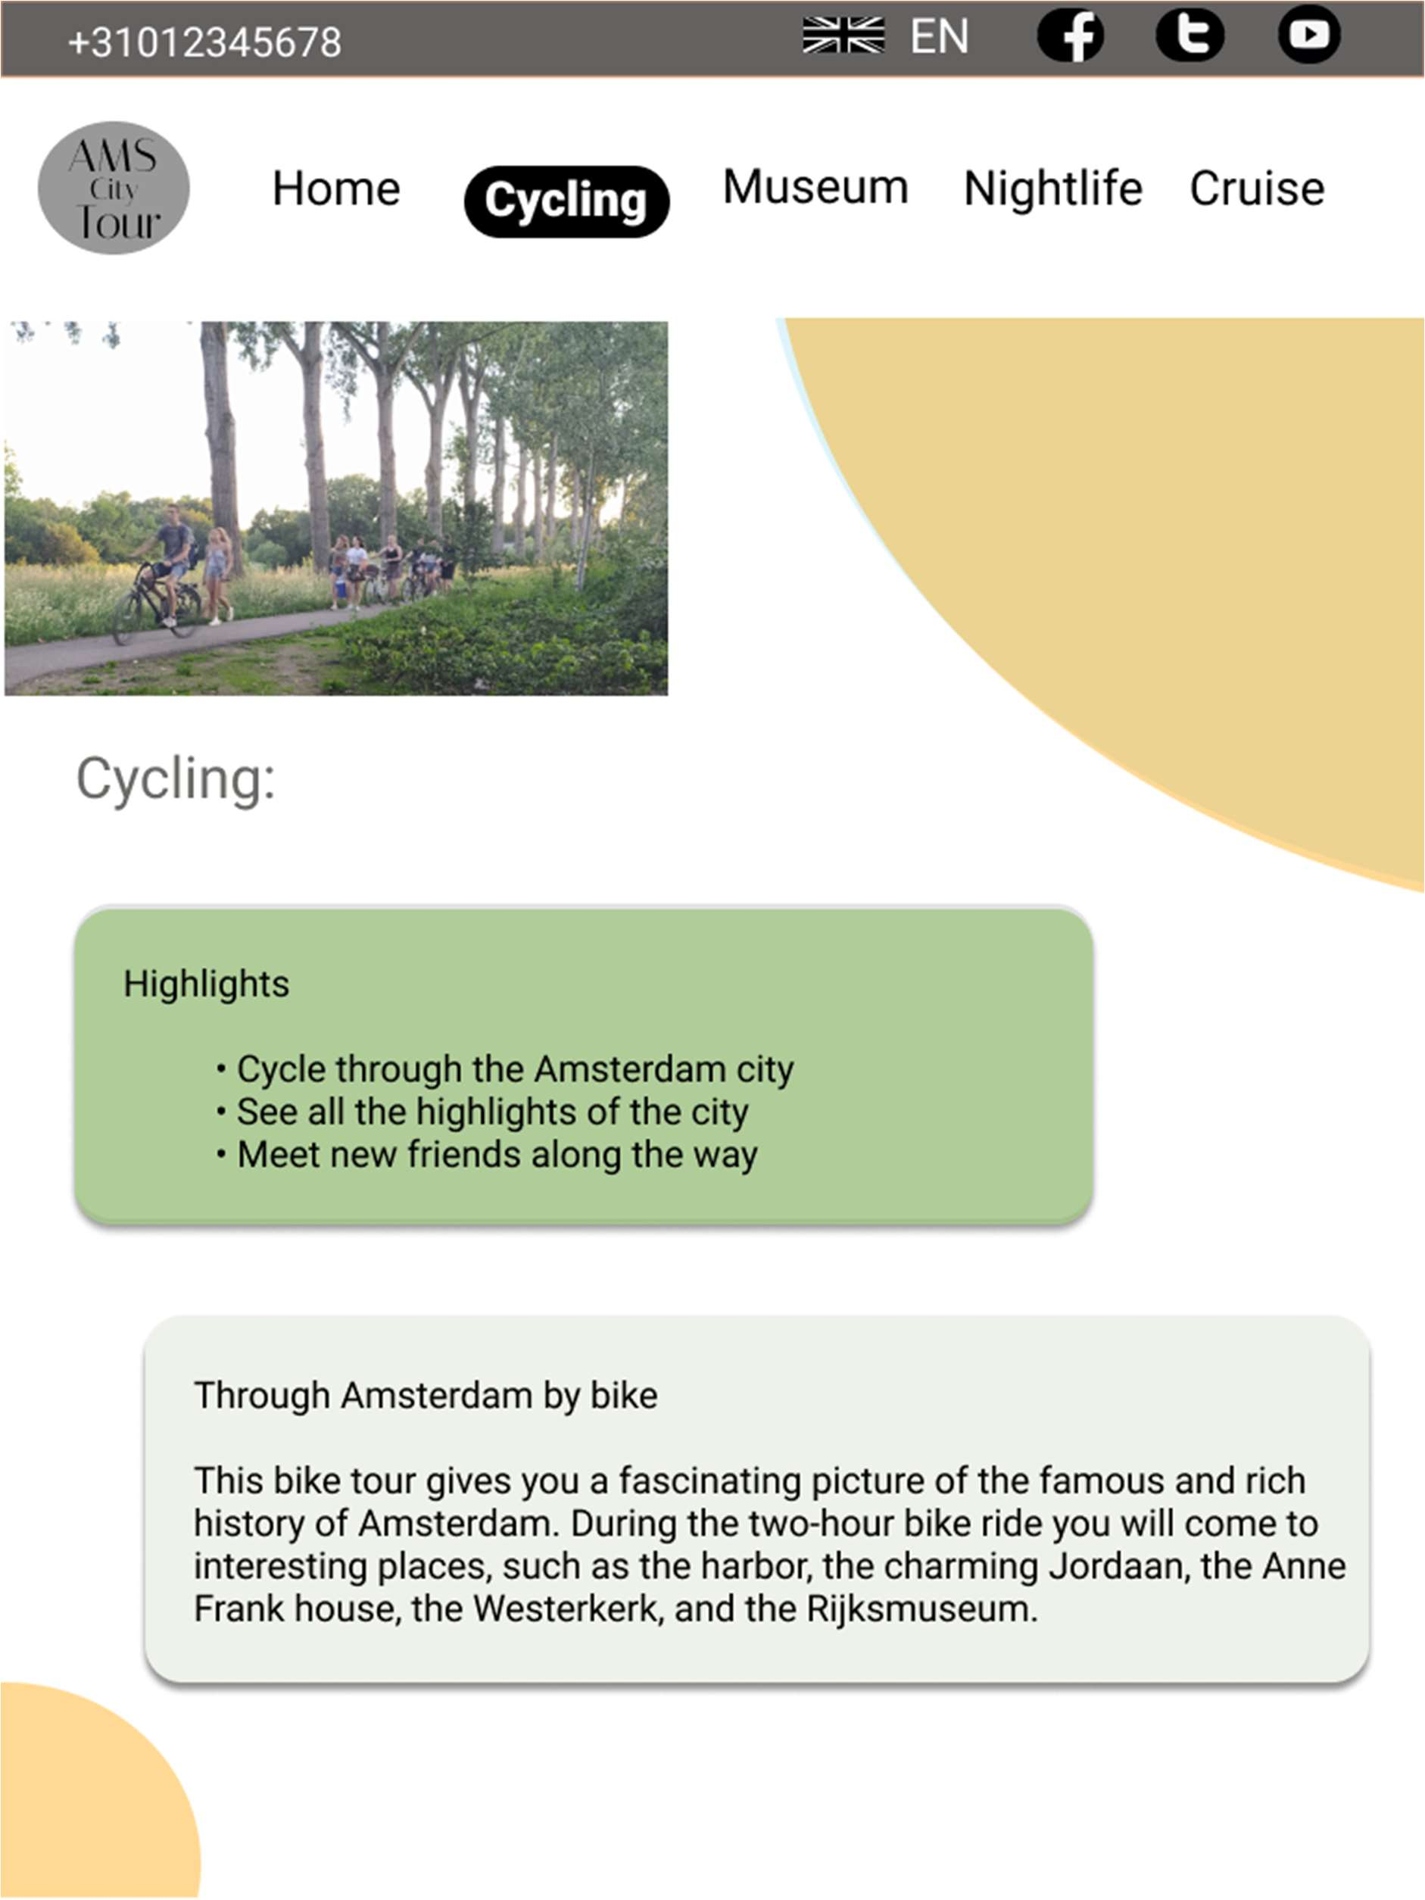

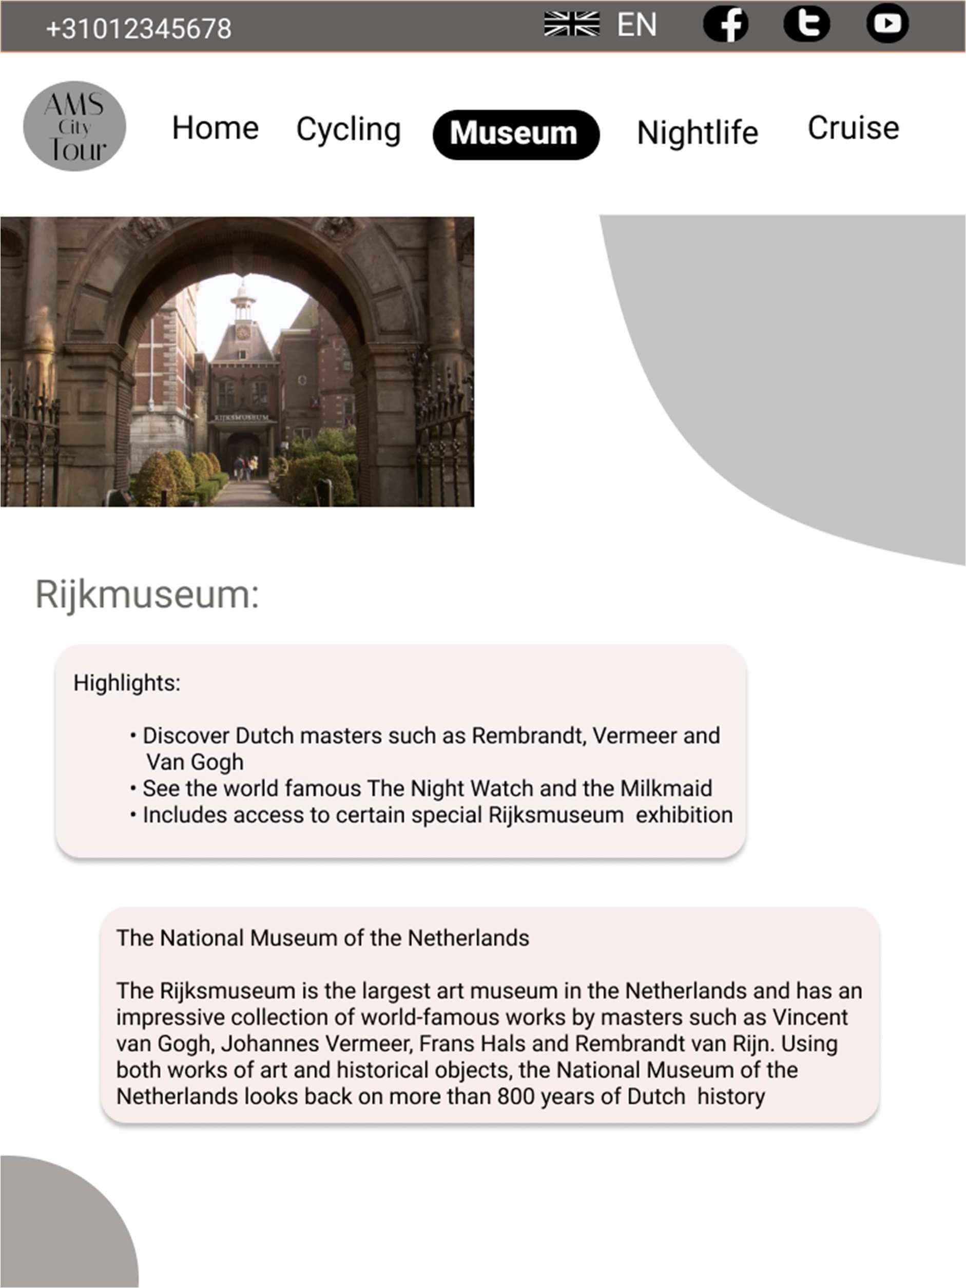

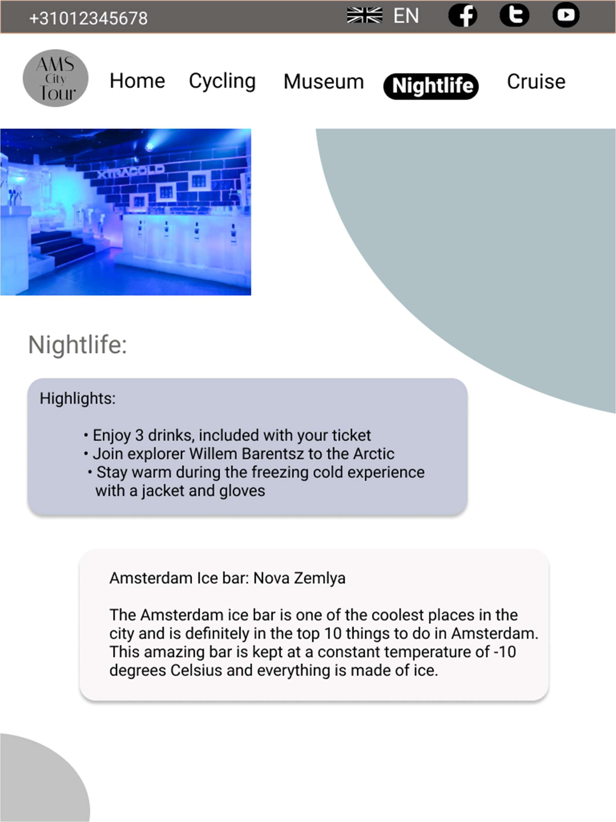

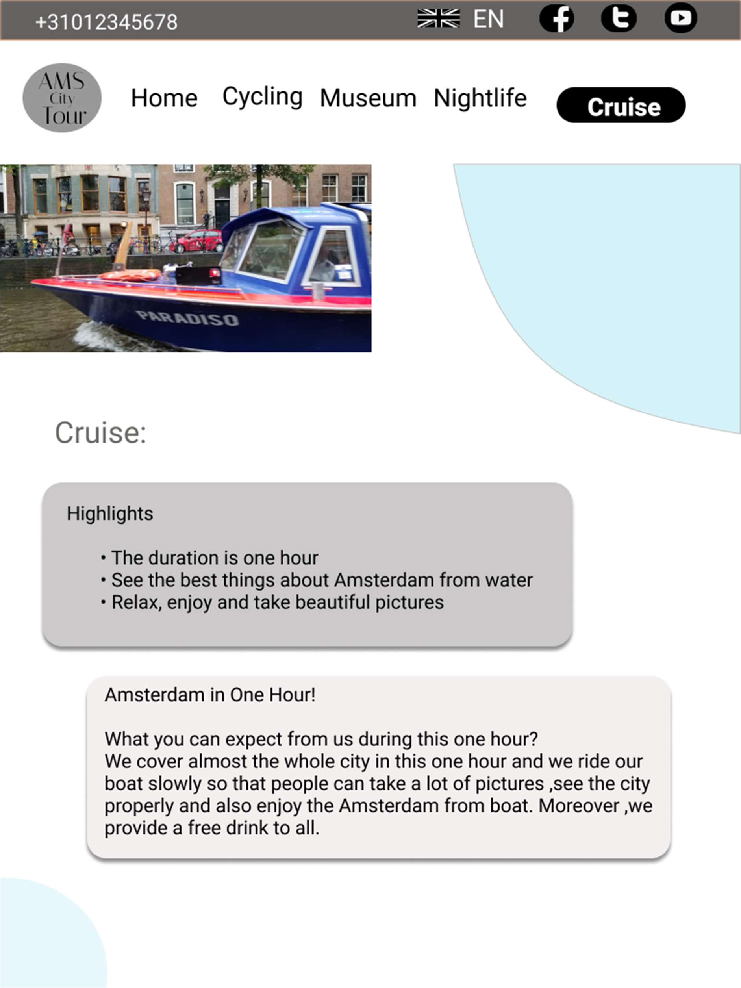

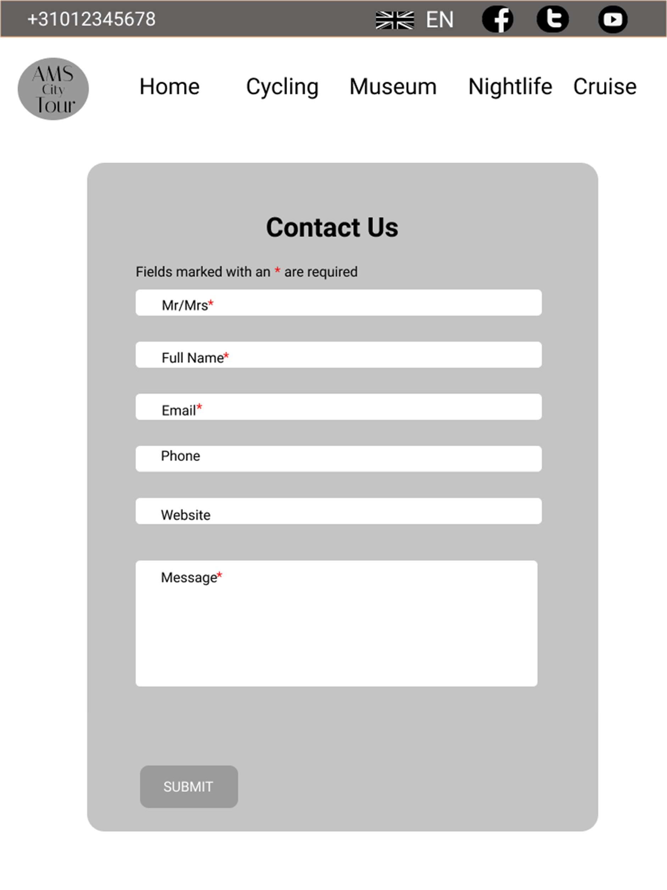

**Desktop:**

https://[www.figma.com/proto/0rfAoWjjl5DHrQn3zv21ju/Untitled?scaling=min-zoom&page-](http://www.figma.com/proto/0rfAoWjjl5DHrQn3zv21ju/Untitled?scaling=min-zoom&page-)

id=0%3A1&starting-point-node-id=214%3A2&node-id=214%3A2

# iPad:

https://[www.figma.com/proto/msvqEvfka6sSl2a89VNV7Q/Untitled?scaling=scale-down&page-](http://www.figma.com/proto/msvqEvfka6sSl2a89VNV7Q/Untitled?scaling=scale-down&page-) id=0%3A1&starting-point-node-id=8%3A2&node-id=8%3A2

# Self Assessment:

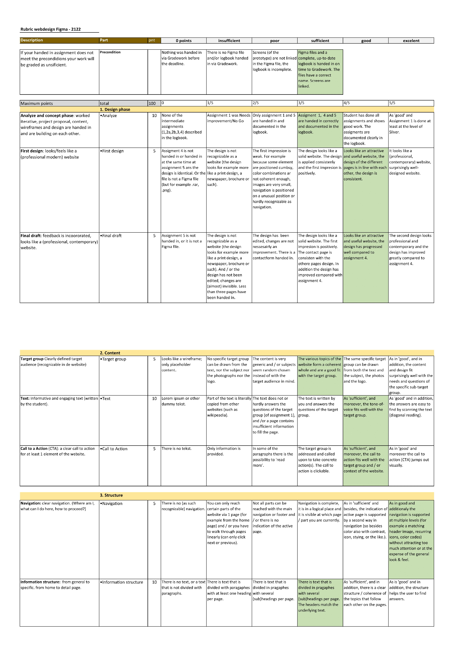

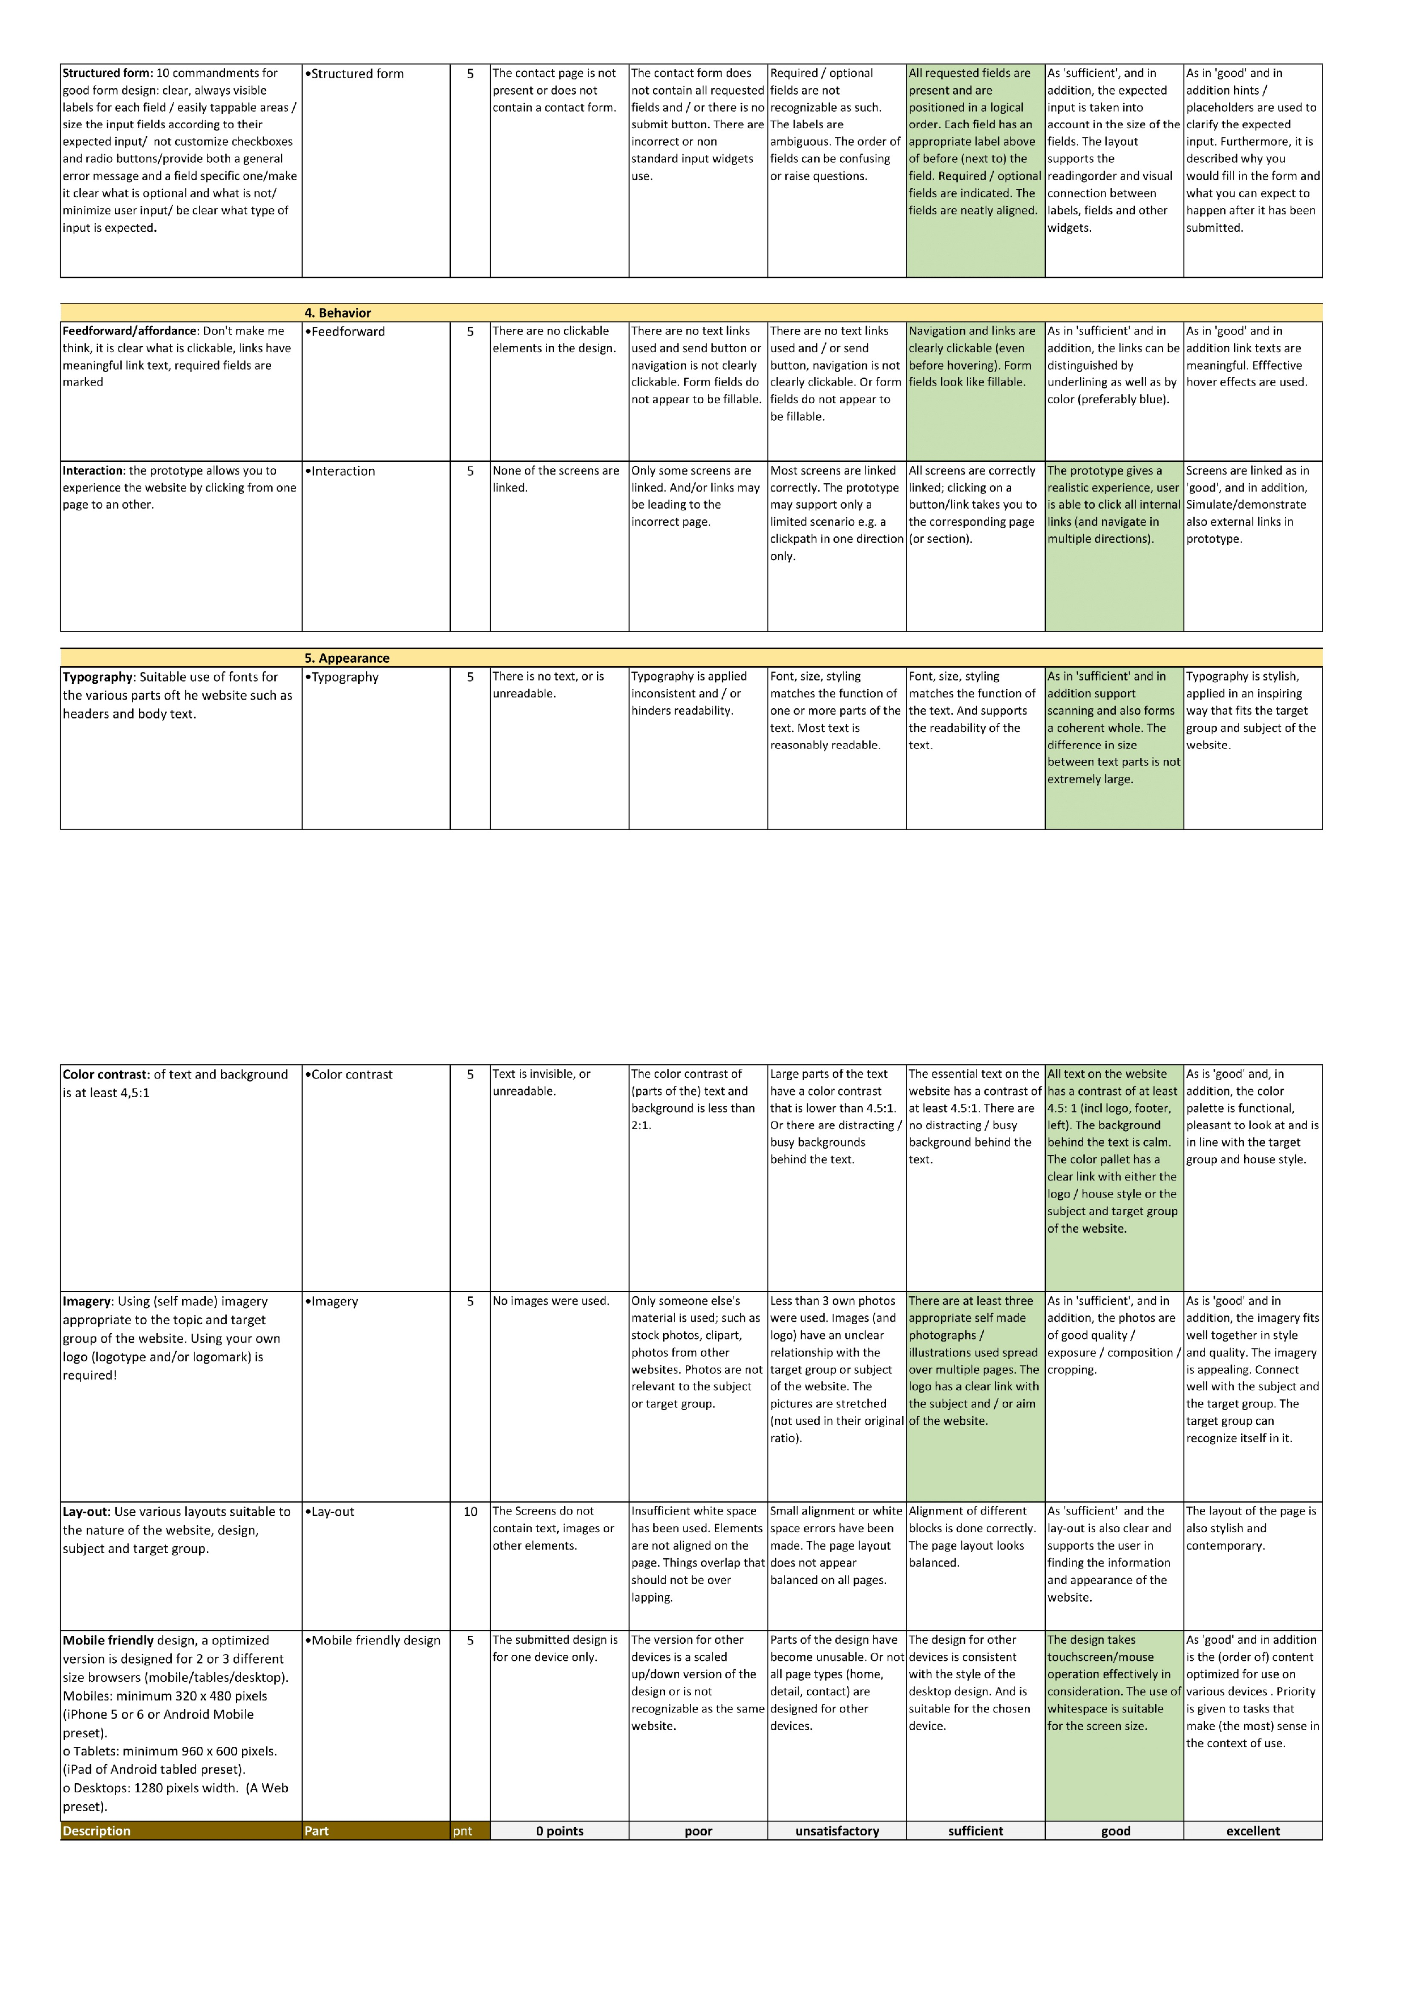

**Sources:**

## [WWW.google.com](http://WWW.google.com/) https://[www.wikipedia.org/](http://www.wikipedia.org/)

|  |  |  |
| --- | --- | --- |
| **Assignment number and title** | **Date your work on the**  **assignment** | **Hours spend** |
| assignment 1: project proposal | 06-09-2021 | 3 hours |
| Assignment 2a | 12-09-2021 | 6 hours |
| Assignment 2b | 19-09-2021 | 6 |
| Assignment 3 | 25-09-2021 | 2 |
| Assignment 4 (Version 1) | 29-09-2021 | 5 |
| Assignment 4 (Version 2) | 15-10-2021 | 2 |
|  | Total Number of Hours | 24 |